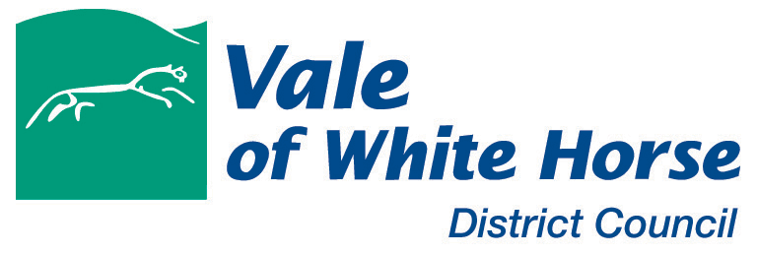
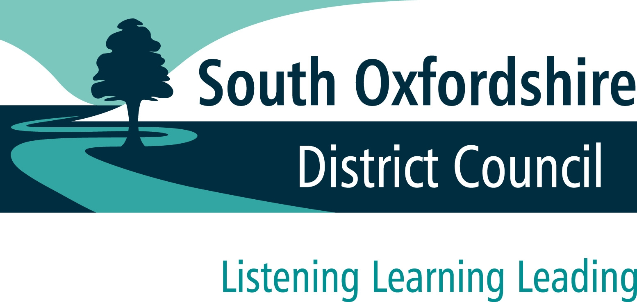
White Horse Lettings – Helping local people remain local

White Horse Lettings is a part of the Housing Advice Team at the Vale of White Horse and South Oxfordshire District Councils. It is dedicated to helping low income families from the Vale and South Oxfordshire remain in their local area while securing good rental returns for private landlords.

White Horse Lettings offers the following services to landlords:

Tenant Identification - FREE OF CHARGE

Any potential tenant put forward to a property has already been interviewed by a Housing Needs Officer to assess their suitability.

Tenancy Agreements - FREE OF CHARGE

For landlords who do not have their own tenancy agreements, White Horse Lettings can supply a personalised agreement free of charge.

Benefits Assistanc e - FREE OF CHARGE

All tenants needing to claim housing benefit are assisted throughout the process by a White Horse Lettings Officer. This is to ensure benefit payments commence promptly following the commencement of a tenancy – normally within one week.

White Horse Lettings can also promptly deal with any housing benefit enquiries.

Entrance and Exit Inventories - FREE OF CHARGE

A White Horse Lettings Officer will conduct an inventory prior to the tenant moving into the property and prior to them moving out to check it is being maintained in good order.

Rent Deposit Guarantee - FREE OF CHARGE

White Horse Lettings can issue a Rent Deposit Bond to guarantee against any loss or damage at the property to the value of 6 weeks rental income. Unlike other schemes, you do not have to pay to register the deposit.

Direct Payment to Landlord - FREE OF CHARGE

White Horse Lettings can also arrange for any housing benefit payments to go directly into the landlord’s bank account if preferred. Housing Benefit payments are payable every 2 weeks to the tenant or every 4 weeks to the landlord.

Strong Rental Returns

Local Housing Allowance determines the level of rental income which landlords can secure for tenants claiming housing benefit. For example, the LHA rate for a 2 bed property in Abingdon or Didcot would be £834.08pcm.*

The fact that White Horse Lettings provides all of its services free of charge, means that the landlord also retains 100% of this rental income.

(please note that although white horse lettings provides a range of free services to landlords, the tenancy agreement is a private contract between the tenant and the landlord.

the tenant (not the council) is legally responsible for paying the rent. white horse lettings will endeavour to resolve any rent issues, however the council is not liable for any arrears accrued during the tenancy. (the same would apply if the property was let through a letting agency). the management of the property, eg repairs, is also the responsibility of the landlord).

If you would like to be registered as a landlord with White Horse Lettings, please sign and return one copy of the enclosed Deposit Bond Scheme – Landlord’s Terms and Conditions agreement to Housing Advice, SODC & VWHDC, 135 Eastern Avenue, Milton Park, OX14 4SB.

Do you have any further questions or a property available to rent?

Please ring 01235 422 442 and ask to speak to Thom Gaunt or Yvonne Jeacock

Yours faithfully

White Horse Lettings
* figures for 2016 & 2017

