Community Food Support for holidays for families with children on free school meals – Week commencing 26/10/20

Vale of the White Horse Community Food network

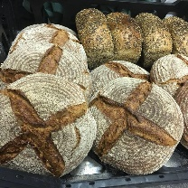 | Marco Polo Bakery | 30 free meals for kids.  Once these have sold out meals for £1 per child. | Phone: 07470462399  Email: marcopolobakery@hotmail.com  https://en-gb.facebook.com/pages/category/Bakery/Marcopolo-Bakery-217155605063717/ | Wantage
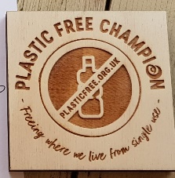 | Willows Shake Shop | Free food for children during half term. Call 20 minutes in advance & collect | Phone: 01235 797621  Email: message on facebook  https://www.facebook.com/willowsshakeshop/?ref=nf&hc_ref=ARR_DzvVFuXHdrqB_mPWkVnP2Qq3r_iIf9eLvAXsnRDOLiJqoEkDviySzDxgHvQCsuE&__tn__=%3C-R | Abingdon
 | M&S Food hall | Kids eat free (Main + Side + Snack + Fruit) when you spend £3 on food @ M&S Café until 30th Oct | https://www.marksandspencer.com/c/offers/terms-and-conditions#CAF%C3%89 | Didcot  Milton Park
 | Annie’s at the Boathouse | From Monday 26th October until Friday 30th October we will be giving away a free lunchbox to any school aged child. Please just give us a call to book your family in. | Phone: 01235 797575  Email: anniestearoom@hotmail.co.uk  http://www.anniesboathouse.com/ | Abingdon
 | The Old Anchor | Free sandwiches for children  Thurs & Fri over half-term  12-12.30  Just show up and collect at the window | Phone: 01235 534123  Email: message on facebook  oldanchorinn.co.uk | Abingdon
 | Sarah’s Bakes | Will drop off a food parcel to anyone who messages her requesting help | Phone: 07468 480403  Email: website@sarahsbakes.co.uk  https://www.sarahsbakes.co.uk/ | Abingdon
 | The Buzz | Free packed lunch for ANY free school meal children within our community tomorrow26/10/10 between 10-1.30  A packed lunch OR a hot meal to eat in or a takeaway on Tuesday to Friday over half term | Phone: 01235 770834  Email: info@buzzcafewantage.co.uk  http://buzzcafewantage.co.uk/ | Wantage  01235 770834  info@buzzcafewantage.co.uk
 | Wildwood Kitchen | Kid’s eat for £1 with every adult main meal purchased until 1 Nov | Phone: 01235 424327  Or book online:  wildwoodrestaurants.co.uk | Wantage
 | SOHA Housing | Free food packages during half term for families that receive free school meals.  Food parcels can be collected from their offices opposite the Didcot train station, Royal Scot House, 99 Station Road, OX11 7NN.  Available by appointment only for collection from Soha offices in Didcot during half term. | Call: 01235 515900 and ask to speak to a member of the resident engagement team.  Email ri@soha.co.uk  Or message via the SOHA facebook page | County wide

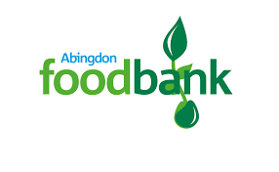 | Abingdon Foodbank | Residents must contact CAB to receive a referral in order to access this food bank.  However, if a family / individual does not have access to food for that day the Food Bank can arrange an immediate food box.  They operate for collection on Wednesdays 1-2.30pm. | CAB: 0300 330 9042  Preston Road Community Centre, Midget Close, Preston Road, Abingdon OX14 5NR | Abingdon
 | Abingdon Community Fridge | This community fridge will deliver a parcel of food which will last at least three days. Ring the community fridge number to refer yourself or someone else. You will need to provide their name, address and contact phone number.  They operate Tuesdays, Wednesday and Saturdays between 10.30am to 11.30am. | abingdoncommunityfridge@gmail.com  07543 852939  The Abbey Centre, Audlett Drive, Abingdon, OX14 3GD | Abingdon
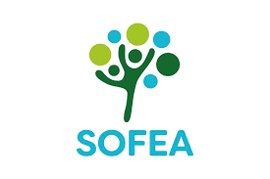 | SOFEA - South Abingdon Community Larder | Residents can join for a membership fee and then access their food as a benefit of membership. They must fill in a form and complete registration on their first visit.  Food boxes can be collected on Fridays between 2.30pm to 4pm. | communitylarder@sofea.uk.com  The Carousel Family Centre, Abingdon, OX14 5GZ | Abingdon
 | CHURCHES TOGETHER IN FARINGDON (CTIF) - FOOD BANK | Residents must contact CAB to obtain a referral form to access this Food Bank.  They are open for collection Mondays and Wednesdays from 10am – 12pm. Delivery of food can be arranged if necessary. | sally@faringdontowncouncil.gov.uk  01367 244 901  CAB: 0300 330 9042  Christ Church Abingdon  Northcourt Road, Abingdon | Faringdon
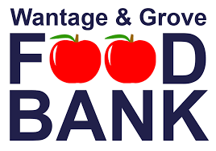 | Wantage and Grove Food Bank | This community fridge will deliver a parcel of food which will last at least three days. Ring the community fridge number to refer yourself or someone else. You will need to provide their name, address and contact phone number. | wantageandgrovefoodbank@gmail.com  07543 852939  Wantage Community Church | Wantage and Grove
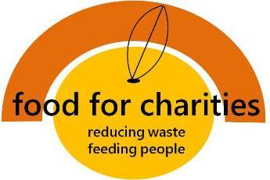 | Food For Charities - Botley Community Fridge | The Botley community fridge is a small fridge with a big heart. Anyone can put food into it, and anyone can take food out. Its main aim is to reduce food waste. The shelving next to it holds non-perishables, and its main aim is to feed people in need.  The fridge is accessible Monday – Saturday from 10am to 4pm, and Sundays from 11am to 4pm. | riki@phonecoop.coop  https://foodforcharities.com/botley/  01865 243488  Church of St. Peter & St. Paul, 81 West Way, Botley OX2 9JY | OX2 - North Hinksey, Botley, Cumnor

