Planning
135 Eastern Avenue Milton Park
Milton OX14 4SB
Email: Registration@southandvale.gov.uk Tel: 01235 422600
Vale
of White Horse
District Council

Do I need planning permission?

(Householder permitted development enquiry)

Please complete this form if you want the Vale of White Horse District Council to advise you whether you need planning permission to extend or improve your house. This is not an official planning application form. The advice we give you will be informal and will be based on the specific information that you have supplied. We charge £52.50 including VAT for this advice service.

You are being asked for your name, address, telephone number and email address so that we can provide you with the advice you have requested. We believe this service is provided to you because it is in your legitimate interests, as well as in the council's, to keep you informed. We will keep these records permanently.

You have the right to request at any time:

- what data we hold about you - please refer to our webpage on data subject access requests, as you may wish to use our specific form for this;

- that incorrect or out of date information about you be corrected;

- that we suspend processing your data for a short while if appropriate;

- that all your data relating to this service be removed from our records.

If you would like to exercise these rights, please contact us on 01235 422600 or by email on registration@southandvale.gov.uk

Our records, and those of our contractors/partners, are regularly monitored by auditors to ensure your information is kept securely and used only for the purposes mentioned above.

If you would like to know more about how we use and store your data, please see our webpage (link to 'data protection and you' http://www.whitehorsedc.gov.uk/about-us/how-we-work/contact-us/data-protection)

To help us provide you with the best service we can, we may ask you to take part in consultations. This would typically involve completing a short questionnaire either on paper or online through our website. You may change your mind at any time.
Please tick this box if you would be willing to take part:

If you believe we have not handled your personal data as we have described here, please either call 01235 422485 or contact us by email to data.protection@southandvale.gov.uk and your concerns will be fully investigated. If, after we have investigated your concerns, you are not satisfied with our conclusion, you

have the right to refer the matter to the Information Commissioner's Office (ICO). You can reach them through this link to their website or call them on 0303 123 1113. Their mailing address is:

Information Commissioner's Office Wycliffe House
Water Lane Wilmslow Cheshire SK9 5AF

Important
A written response from the council will not protect you from possible enforcement action if the works you carry out are subsequently found to require planning permission, or if the works are different to that set out in the information you have supplied. You need to apply for a Lawful Development Certificate if you would like a formal determination on whether your proposed works require planning permission.
Briefly describe what you want to do and then answer the relevant questions below which are relevant to your enquiry
Contact details

Name: ...............................................................................................................................

Email: ........................................................................................................................... ....

Address: ........................................................................................................................... .

.........................................................................................................................................
Post code: ....................................... Daytime Telephone Number: .........................................

Details of the property (if different to above)
Address: .............................................................................................................................
..........................................................................................................................................

Post code: ...........................................................................................................................
Is the property detached, semi-detached or terraced? ...............................................................
NB planning permission is always required to extend or materially alter the external appearance of flats (apart from, in some cases, installing solar panels).

Please answer the following questions if you propose to build an extension

a) The proposed extension is: | Two storey | Single storey Conservatory
b) In relation to the existing house the proposed extension is on the: | Front | Rear Side

- The external dimensions of the proposed
extension (in metres) are: Depth Width Height

- Will the extension be closer than 7 metres to the rear boundary? Yes No

- Will the extension be closer than 2 metres to any other boundary?

- Will its width be greater than half the width of the original house?

- Will the ridge height of the extension be higher than the existing house?

- Will the eaves be higher than the eaves of the existing house?

- Will the extension, when added to any previous extension(s) and other buildings in the garden, cover more than half the garden area?

- Will there be a veranda or balcony added to the extension?

- Will the side elevation contain a window with a cill height lower than 1.7m above the floor?

I) Will the materials match the existing house?
Yes No

Yes No

Yes No

Yes No

Yes No

Yes No

Yes No

Yes No
Please answer the following questions if you propose to convert your loft or alter the roof
a) Will the total volume of the additional roof space
(including any previous additions) exceed 40 cubic metres?
Yes
No
b) Will the total volume of the additional roof space
(including any previous additions) exceed 50 cubic metres?
Yes
No
c) Will the roof extension project beyond the plane of the existing roof slope above the principal elevation fronting the
highway?
Yes
No
d) Will the highest part of the extension be higher than the

highest part of the original roof? | Yes | No
e) Will the materials match the existing roof? | Yes | No
f) Will there be a balcony attached to the roof extension? | Yes | No
g) Will the cill height of any new side facing window be lower than 1.7m above floor level? | Yes | No
h) Will the roof extension be set back at least 20cm from the eaves? | Yes | No
i) Will any Velux window project more than 150mm from the existing roof plane? | Yes | No

Please answer the following questions if you propose to add a porch to any external door
a) Will the ground area (measured externally) exceed 3 sq. metres?
Yes
No
b) Will any part of the porch be more than 3 metres above ground level?
Yes
No
c) Will any part of the porch be within 2 metres of any boundary facing a highway?
Yes
No

Please answer the following questions if you propose to -
- add, improve, alter or maintain any building, enclosure, swimming pool or other pool in your garden for your personal use, or
- install a container for the storage of oil or liquid petroleum gas for domestic heating purposes:

NB any development of this nature requires planning permission if it is in the garden of a listed building
- The external dimensions of the proposed building/structure

(in metres) are: Depth Width Height

- Will any proposed building have a pitched roof?

- Will any proposed building be within 2 metres of any boundary?
Yes No

Yes No

- Will any building project forward of the principal elevation fronting
the highway? Yes No

e) Will the building, enclosure, pool or container be on the side of the house? | Yes | No
f) Will any proposed oil or gas container have a capacity exceeding 3,500 litres? | Yes | No
g) After the proposed works, will more than half the garden area  of the original house be covered by buildings and extensions/additions? | Yes | No
The term 'original house' means the house as it was originally built (or as it stood on 1 July 1948 if it was built before that date). Although you may not have built an extension, a previous owner may have done so.
- Will the proposed works consist of or include a veranda, balcony or
raised platform with a height greater than 300 mm? Yes No

No
Yes
c) Are you creating a new vehicle access across a pavement or verge?
No
Yes
b) Are you creating a new or altered vehicle access?
......... Metres
Please answer the following questions if you propose to create • a fence, wall or gate, or a new or altered vehicle access

a) How high will the proposed fence, wall or gate be?

No
Yes
e) Are you going to demolish a building to make way for the new surfaced area?
No
Yes
No
Yes
- Will the new surface be made of permeable or porous material such as gravel, permeable concrete block or porous asphalt?
- If the answer to (c) is No, will water be able to run off onto a permeable or porous surface or an area such as a lawn or flower bed?
No
Yes
b) Will the surface being laid down or replaced be more than 5 sq. metres?
No
Yes
Please answer the following questions if you propose to create -
a hard standing or driveway OR to replace one, in whole or in part:

a) Will the hard surface be situated in the garden between the front of the house and the road?

Please use the space on the next page of this form to draw a plan and sketch of your proposal. Include neighbouring properties and adjacent roads. Please attach any other information you believe may be relevant, particularly photographs of your property.

Your Sketch Plan

Sample Plan
Please provide a sketch plan like the one below giving all the details shown. A Show the distance
between proposed outbuilding
and the property boundaries.

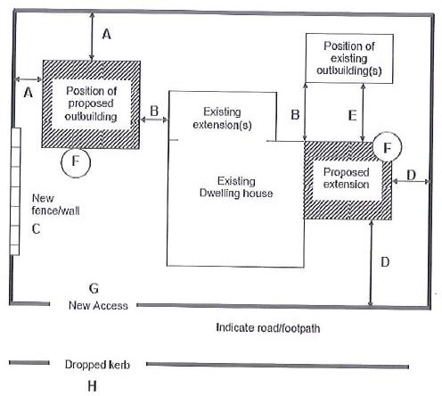
  - Show the distance between any proposed or existing outbuildings and the existing dwelling.

  - Position and height of the boundary fence/wall (if one is proposed).

  - Show the distance between proposed extension and the property boundaries.

  - Show distance between proposed extension and any existing outbuildings

  - Position of any trees/hedgerows that may be affected.

  - Position of new access (if one is proposed).

  - Position of existing or proposed dropped kerb.

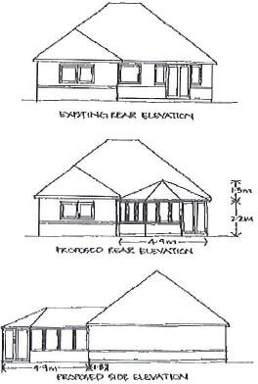
SAMPLE ELEVATIONS:
include dimensions as appropriate

