Woodlands MHP Radley
Ash 1115 – Fell Ground level leave all arisings in woodland cut up – stem may be left in lenghts

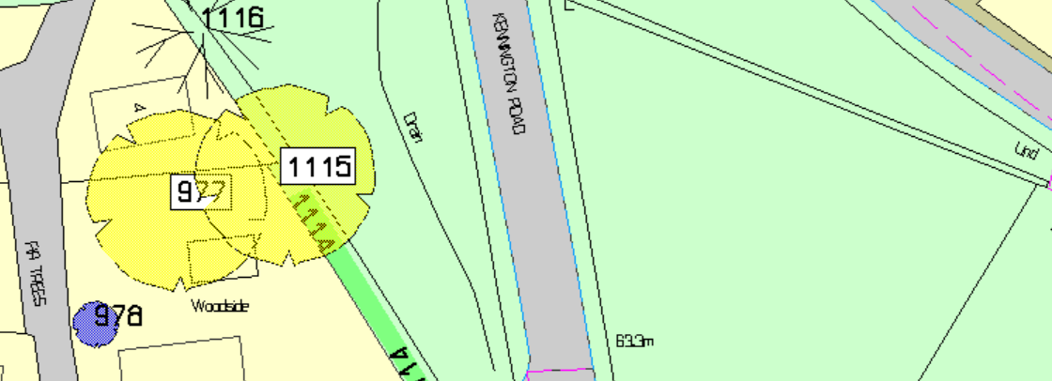

Ash 1152, 1153 and 1154 – Fell at ground level chips and 2m cut stacks can be left in woodland 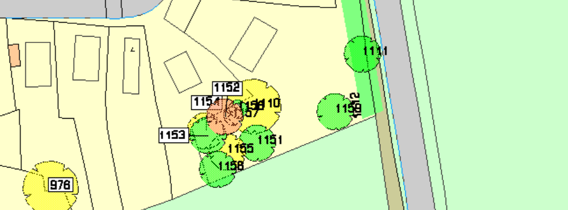
Ash 968 – Fell and remove all arisings from site

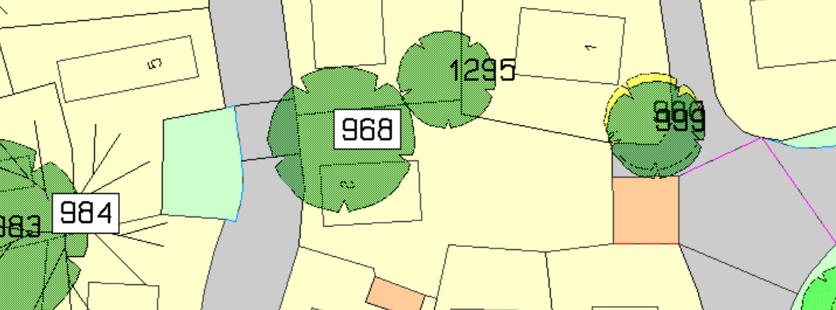

Oak 782 – Crown reduction 20% 3m esp on MH side and rem dead wood

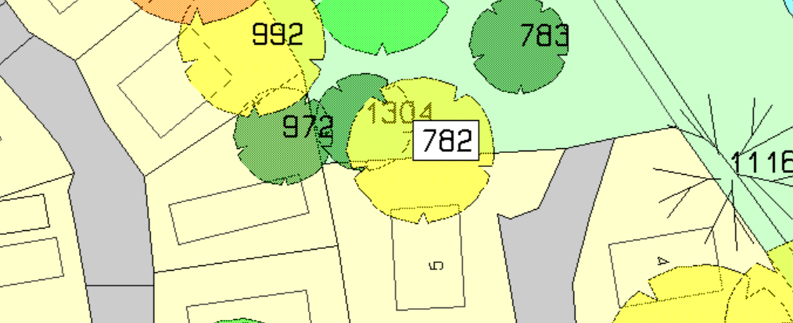

Ash 972 – Fell - arisings to be removed
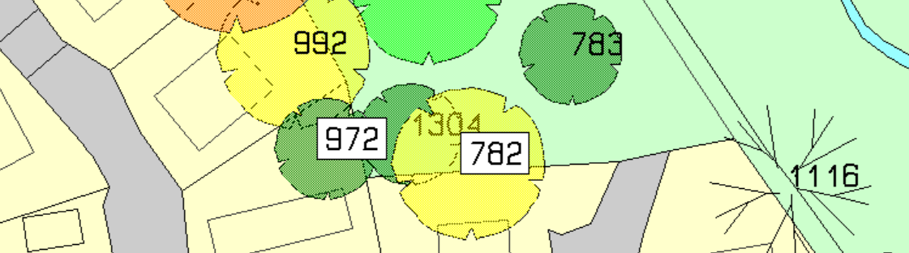

Oak 992 – 30 % 5m crown reduction - arisings can be put in woodland

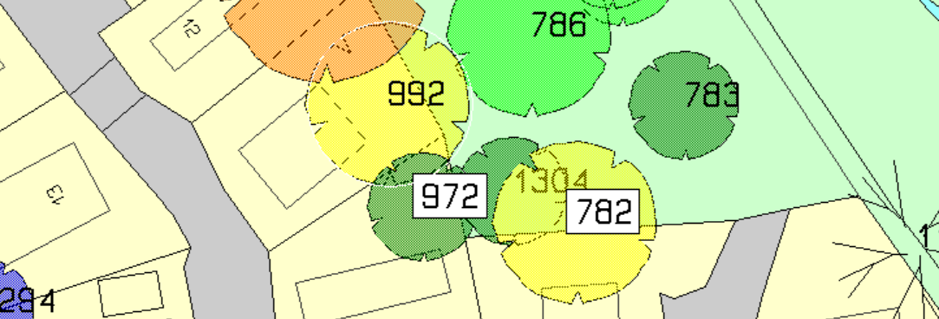

Ash 974 – Fell remove all arisings
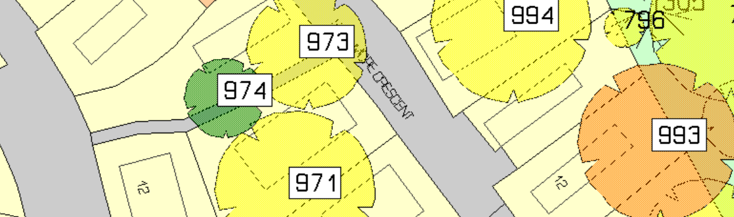

Ash 998 – Fell and remove all arisings

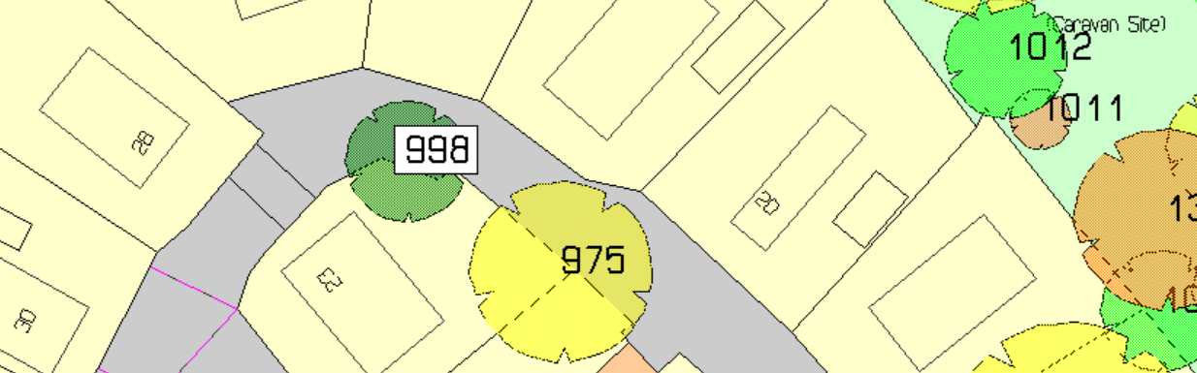

Oak 1246 Crown reduction 20% 4m Arisings to be removed from site
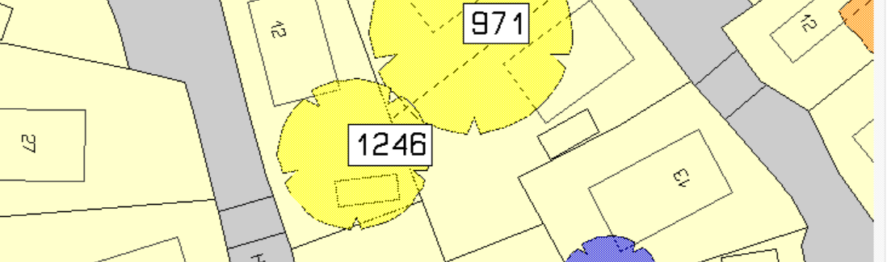

Oak 986 – Crown reduction 25% 4m and major reduction of large branches with decay
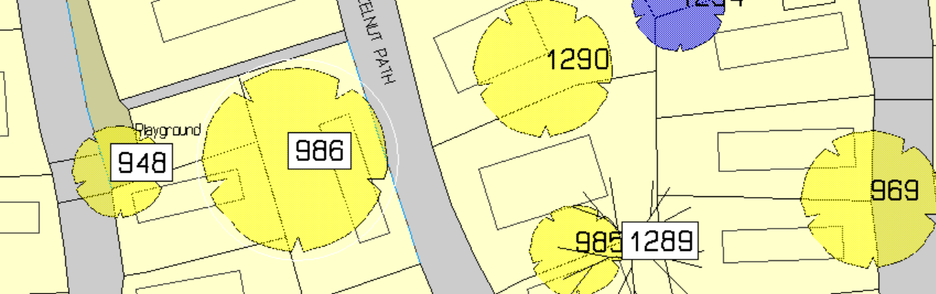

Oak 954 – Crown reduction 20% remove dead and shorten laterals by 4m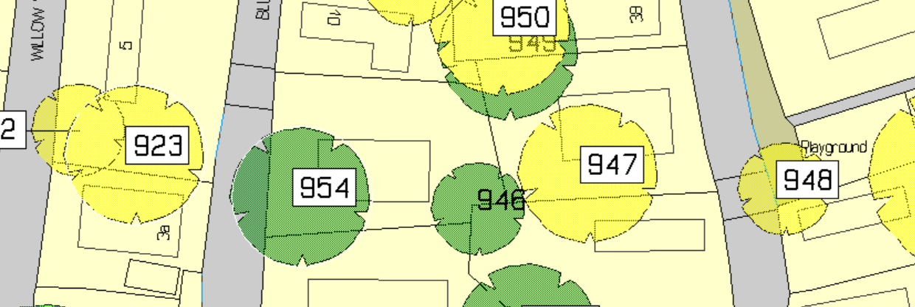

Oak 923 rem all dead wood back to growth points
Oak 954 30% crown reduction rem all deadwood
O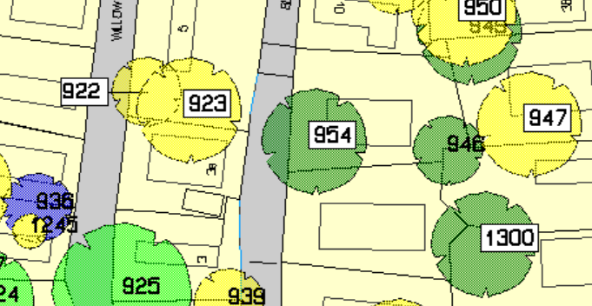
Oak 930 reduce lateral large branches over parking and amenity areas
Oak 961 20% 4m reduction back to where previously cut

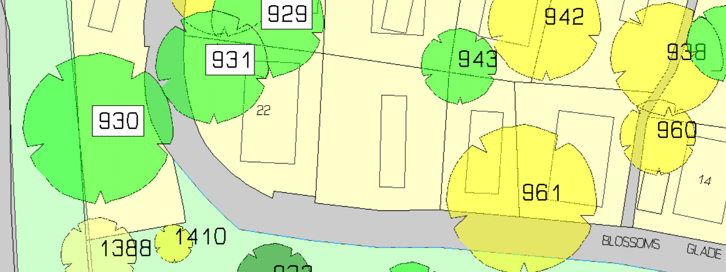

Oak 959 rem dead wood and reduce canopy by 20% 3m

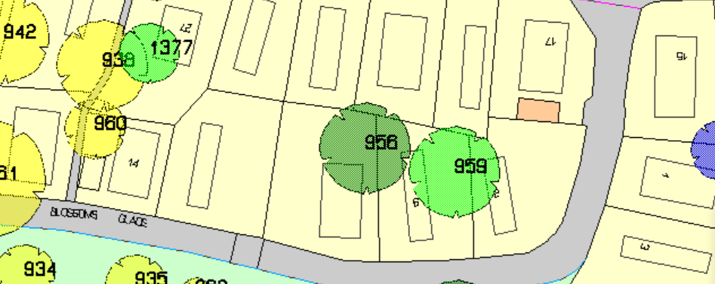

Oak 961 reduce canopy 20 % 4m back to where previously cut

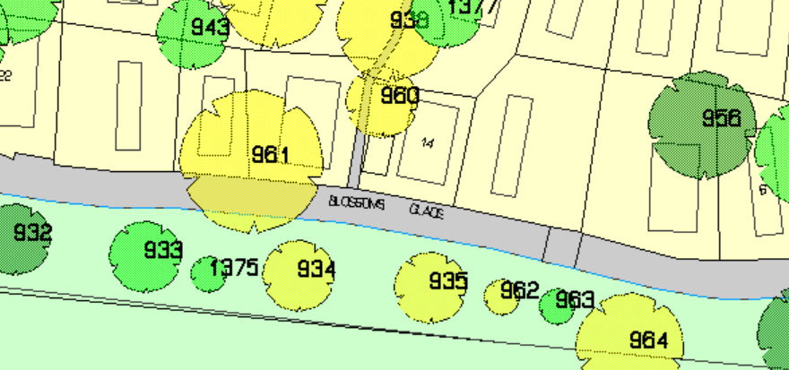

Pebble Hill MHS Radley

Oak 1297 40% crown reduction

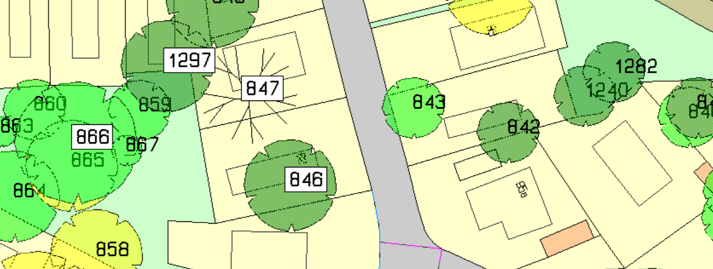

Oak 852 prune 1.5m sides over MHs and remove all deadwood
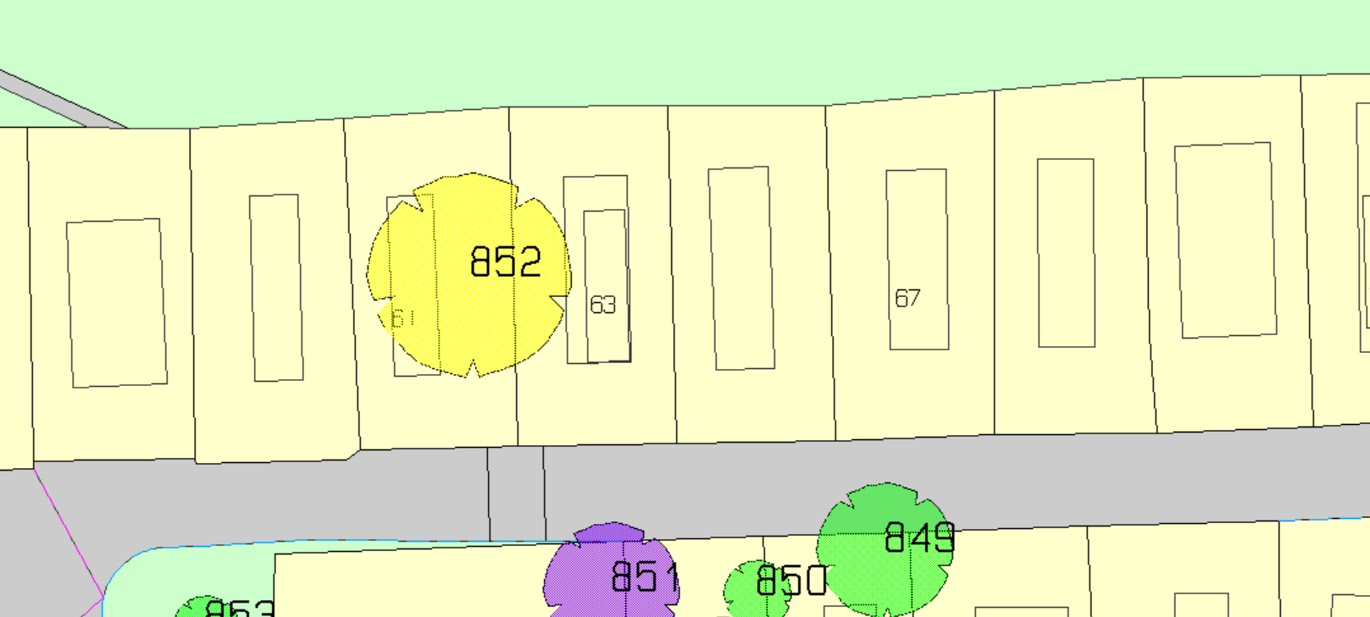
Oak 855 reduce crown 20% 4m esp on south side to rebalance

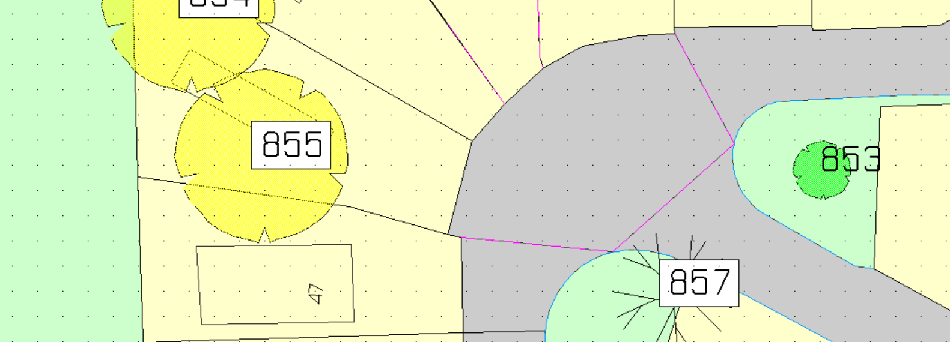

Oak 1277 cut back overhang of MH and rem all deadwood
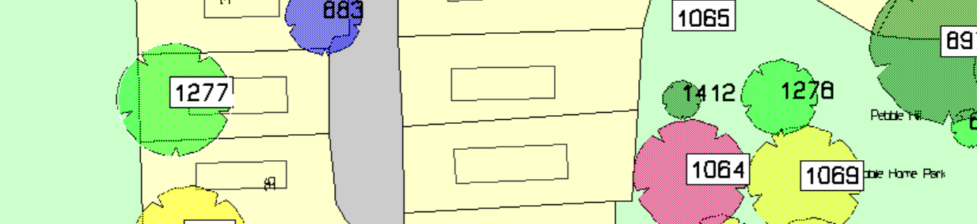

Ash 1064 Fell Chippings and logs cut to 0.5m can be left in woodland
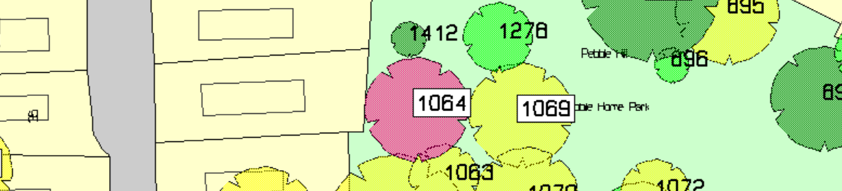

Oak 1062 30% crown reduction esp overhang of MH plot

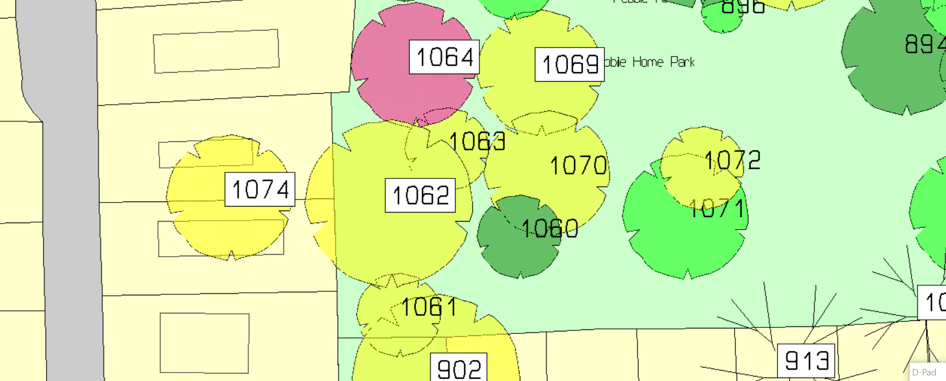

Oak 1005 20% 3m Crown reduction and rem all deadwood and low hanging branches near MH
Field Maple 899 40% crown reduction
H Chestnut 900 fell and rem all arisings
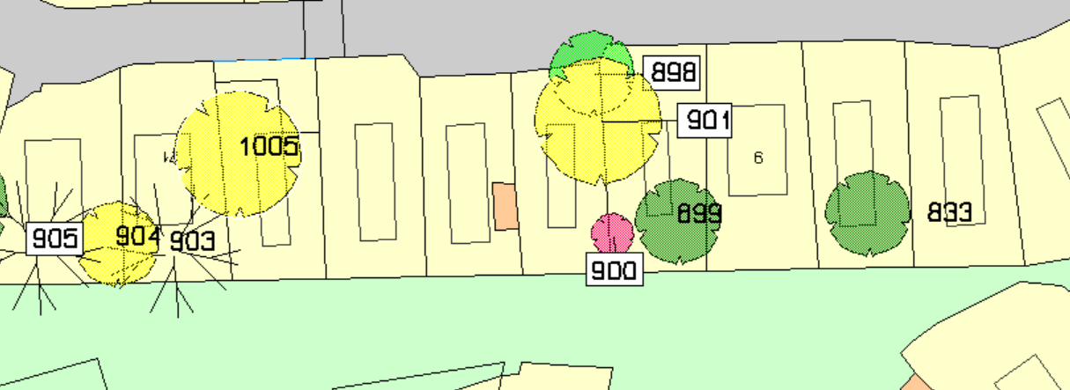

Ash 877 fell all arisings to be removed
Field Maple 914 50% crown reduction
