Botley Centre Draft
Supplementary Planning Document (SPD)
Consultation Statement

The Vale of White Horse District Council (Vale) Statement of Community Involvement (SCI) adopted December 2009 requires consultation on draft Supplementary Planning Documents (SPD) to include a statement setting out how the council has complied with the Vale SCI. This statement must be made available for inspection at the council offices in Abbey House and Milton Park.

According to the Vale SCI, the main stages for preparing a Supplementary Planning Document are set out below:

Figure 1. Process for preparing a Supplementary Planning Document
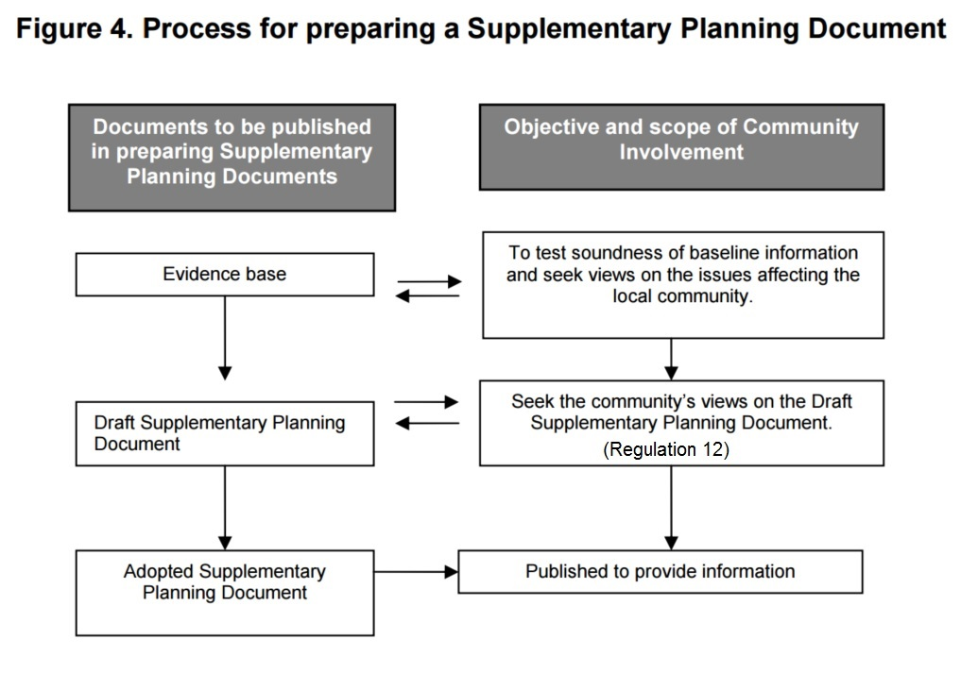

Consultation for the Botley Centre Draft SPD is been carried out by regulatory requirements set out in the Town and Country Planning (Local Planning) (England) Regulations 2012 and the Vale SCI. Further to complying with regulation consultation activities, the council perused additional activities where resources permitted. Table 1 sets out how the council has complied with the SCI.

The Vale SCI specifies particular consultation requirements and goes on to recommend consultation activities that can be pursued if the council considers it will add value to the consultation exercise and make it easier for the community to be involved. The colour key below distinguishes between required consultation activities and those that are optional.

Green | Denotes consultation activities that are required either by the Vale SCI or Town and Country Planning (Local Planning) (England) Regulations 2012
Orange | Denotes consultation activities that are optional, and where the council is going above and beyond regulations set out in the Vale SCI

Table 1. Vale SCI Compliance Table

Consultation Activity | How the council has complied with regulation | Date Completed
EVIDENCE BASE
5.35. Contact relevant organisations to be affected by the proposed SPD | The council has actively engaged a number of stakeholders, organisations, landowners, and other groups to inform groups of the emerging site proposals | March 2015 –  April 2015
5.35. Use the council’s website to provide information about the proposed SPD | During the evidence base stage of the SPD, the council’s website outlined the following details:  - Botley SPD Project description  - Explanation of why the Vale was producing the document  - Key dates of consultation start and finish  Website link:  www.whitehorsedc.gov.uk/botleyspd | July –  21 August
5.35. Meet with key interested parties and organisations | The council met with a number of key interested parties and organisations including:  - WWCC  - North Hinksey Parish Council  - Cumnor Parish Council  - Botley Baptist Church  - St. Peter and St. Paul Church  - landowners/developers | April 2015 –  July 2015
5.36. Use questionnaires to gauge public opinion SPD policy issues | A questionnaire was not developed as part of the evidence base stage. However, a response form will be used to record consultee representations and gauge public opinion of the draft SPD. | N/A
5.36. Hold a stakeholder working group and/or public workshop for topic based or site specific SPD documents | The council has hosted presentations and workshops with a number of key stakeholders.  Presentation – 21 May 2015  Attendance:  - North Hinksey Parish  Stakeholder workshop – 4 June 2015  Attendance:  - West Way Community Concern  - Botley Baptist Church  - North Hinksey Parish Council  - Cumnor Parish Council  - St. Peter and St. Paul Church  - District Councillors  Presentation – 22 June 2015  Attendance:  - West Way Community Concern  Viability workshop – 27 June 2015  Attendance:  - West Way Community Concern  - Botley Baptist Church  - North Hinksey Parish Council  - St. Peter and St. Paul Church  - District Councillors | See dates.
5.36. Set up public exhibitions or workshops to understand wider public opinion | A public exhibition or workshop was not held as part of the evidence base consultation stage. However, two public exhibitions will be held during the consultation on the draft SPD. | N/A
5.46 Consult on the Evidence Base and Sustainability Scoping Report. | The council consulted with Historic England, Natural England and Environment Agency on the Sustainability Appraisal scoping report in accordance with SA Regulations. | 21 July 2015
DRAFT SPD
5.38. Send ‘specific’ and ‘general’ consultation bodies a copy of the draft SPD and Consultation Statement | The council has notified statutory and general consultation bodies of the consultation time frame, where they can access and inspect a copy of the SPD, and the time and date of planned exhibition events. Due to environmental considerations, consultation bodies are not provided hard copies of the draft SPD and Consultation Statement. Copies are available for download on the council website:  www.whitehorsedc.gov.uk/botleyspd  This consultation requirement complies with government regulations 11-16 and 35 of Town and Country Planning (Local Planning) (England) Regulations 2012 | 19 August –  21 August
5.38. Make draft SPD and Statement setting out how the council has complied with the SCI available for inspection at the LSP at Abbey House | Hard copies of the draft SPD and Consultation Statement are available for inspection in the following places:  - council offices at 135 Eastern Avenue, Milton Park, Milton, OX14 4SB  weekdays from 9.00am to 5.00pm (4.30pm Fridays)  - council offices at Abbey House, Abbey Close, Abingdon, OX14 3JE  weekdays from 8.30am until 5.00pm (4.30pm Fridays)  This consultation requirement complies with government regulations 11-16 and 35 of Town and Country Planning (Local Planning) (England) Regulations 2012 | 21 August
5.38. Publish draft SPD and Consultation Statement on the council’s website | The council’s website includes a link to download the draft SPD and Consultation Statement. Website link:  www.whitehorsedc.gov.uk/botleyspd  This consultation requirement complies with government regulations 11-16 and 35 of Town and Country Planning (Local Planning) (England) Regulations 2012 | 21 August
5.38. Publish a notice in a local newspaper stating where the draft SPD and Consultation Statement are available for inspection and the period of consultation | A public notice was published in the Oxford Times, 20 August 2015. The Oxford Times has the highest readership in the Botley area and as such, was selected to run publication of the public notice. The council is also publishing a notice in the September issues of The Sprout, a North Hinksey newsletter, and the Cumnor Parish News.  This consultation requirement complies with government regulations 11-16 and 35 of Town and Country Planning (Local Planning) (England) Regulations 2012 | 20 August –  1 September
5.39. Use council website to provide information and seek views on the draft and publicise public exercises | The council’s website includes a detailed description about the Botley SPD consultation process, links to all relevant documents (SPD, SA, etc.), info on how to make comments, and dates for upcoming exhibition events. The council’s website is continuously updated as new information becomes available. | 21 August –  ongoing
5.39. Make the draft SPD and Consultation Statement available for inspection at all relevant local libraries | Hard copies of the draft SPD and Consultation Statement are available for inspection in the following public libraries:  - Botley, Oxford Central, Abingdon, Wantage, and Faringdon. | 21 August
5.39. Inform other organisations who may have interest in the Supplementary Planning Document and individuals who have asked to be kept informed that the document is available. | The council has maintained ongoing communication with key stakeholders that have been engaged throughout the development of the draft SPD. A number of these organisation have asked to be kept informed. Many of these individuals are included in our ‘general’ consultation bodies and have previously been notified through email or post (SCI 5.38) | 21 August
5.40. Continue to meet with key interested parties | The council intends to maintain communication with key stakeholders that have been engaged throughout the development of the draft SPD. Meetings have not yet been scheduled, however, when possible, the planning staff will attend community group meetings to provide relevant information about the draft SPD consultation. | TBD
5.40. Hold public workshops and/or focus group meetings for site specific SPD | The council is hosting two exhibition events to promote consultation to residents and users of the West Way shopping centre area. Exhibitions will provide an opportunity for members of the public to talk to members of staff and ask questions about the draft SPD. Static displays will be left in the storefront window of the West Way shopping centre from 5th September. Unmanned exhibitions will allow continued promotion of the consultation with main users of the West Way shopping centre.  Location: Unit 24 West Way Shopping Centre, Chapel Way, (adjacent to Cooperative Travel) | 3 September  6.30-8.30pm  5 September  10.00am-Midday
5.40. Use questionnaires to gauge public opinion | A response form has been developed to record consultation responses during the five week response period. The response form includes a combination of single-choice (quantitative) and open-ended (qualitative) questions. We encourage those responding to use the prescribed representations form, which is available to download from the council’s website:  www.whitehorsedc.gov.uk/botleyspd | 21 August –  25 September
5.40. Distribute leaflets containing information on where the documents can be viewed and the date(s) and venue(s) of any community involvement exercise | The council intends to have leaflets distributed in the West Way shopping centre area throughout the five week consultation period, particularly to advertise the exhibition events 3 and 5 September. The leaflets will include information on where the documents can be viewed and when and where the exhibition will be held. | TBD
5.40. Advertise the publication of draft SPD documents by placing posters in local area. | To advertise the consultation, a large A1 poster with relevant information will be displayed in the storefront of Unit 24 West Way Shopping Centre, Chapel Way, (adjacent to Cooperative Travel) from 21 August through 25 September. Additionally, smaller posters will be distributed to community groups, posted on North Hinksey and Cumnor Parish Council notice boards (with prior consent), bulletin boards, with local businesses and other high-trafficked community spaces. | 21 August and ongoing distribution
5.40. Use existing Citizens Panel and Youth Forum to gauge opinion | The Citizens Panel and Youth Forum are no longer active bodies and therefore, have not been engaged as part of the draft SPD consultation. | N/A
5.41 Consider and analyse representations received and make necessary changes. A final version for the SPD will be prepared along with a statement that summarises the main issues raised and how they have been addressed. | The council will carefully consider and analyse representations, make changes it considers necessary and prepare a statement of the main issues raised and how they have been addressed. All comments submitted may be available on the council’s website for public inspection. | 21 August –  Mid October
5.45. When proposed submission document is published for comments, invite comments on the Sustainability report | The Sustainability Appraisal report is open for public consultation at the same time as the SPD. Consultees are encouraged to comment on the SA using the response form available on the council’s website:  www.whitehorsedc.gov.uk/botleyspd | 21 August
5.46. Send copies of SA to Historic England, Natural England and the Environment  Agency | The council has sent hard copies of the Sustainability Appraisal to Historic England, Natural England and the Environment  Agency | 19 August –  21 August
5.47. Make SA available to view and download on the council’s website | The Sustainability Appraisal Report for the Botley SPD is available for download on the council’s website:  www.whitehorsedc.gov.uk/botleyspd | 21 August
5.47. Make SA available for inspection or purchase at the Local Service’s Point at Abbey House, Abingdon | Hard copies of the Sustainability Appraisal Report are available for inspection in the following locations:  - council offices at 135 Eastern Avenue, Milton Park, Milton, OX14 4SB  weekdays from 9.00am to 5.00pm (4.30pm Fridays)  - council offices at Abbey House, Abbey Close, Abingdon, OX14 3JE  weekdays from 8.30am until 5.00pm (4.30pm Fridays)  Full colour, bound copies of the SA are also available for purchase for £8.61 each + vat.  To order, please contact:  Hobs Reprographics Abingdon  Manger, Harry Darlington  Telephone – 01235 833044 | 21 August
5.47. Send a paper copy and an electronic copy to the Planning Inspectorate | A hard copies and an electronic copy of the Sustainability Appraisal Report were sent to the Planning Inspectorate | 19 August –  21 August
5.47. Make document available for inspection at relevant local libraries in the district. | Hard copies of the Sustainability Appraisal Report are available for inspection in the following public libraries:  Botley, Oxford Central, Abingdon, Wantage, and Faringdon. | 21 August
 | December consultation
5.38. Publish a notice in a local newspaper stating where the draft SPD and Consultation Statement are available for inspection and the period of consultation | A public notice was published in the Oxford Times, 19 November 2015. The Oxford Times has the highest readership in the Botley area and as such, was selected to run publication of the public notice.  This consultation requirement complies with government regulations 11-16 and 35 of Town and Country Planning (Local Planning) (England) Regulations 2012 | 19 November
5.38. Publish draft SPD and Consultation Statement on the council’s website | The council’s website includes a link to download the draft SPD and Consultation Statement. Website link:  www.whitehorsedc.gov.uk/botleyspd  This consultation requirement complies with government regulations 11-16 and 35 of Town and Country Planning (Local Planning) (England) Regulations 2012 | 20 November
5.39. Use council website to provide information and seek views on the draft and publicise public exercises | The council’s website includes a detailed description about the Botley SPD consultation process, links to all relevant documents (SPD, SA, etc.), info on how to make comments, and dates for upcoming exhibition events. The council’s website is continuously updated as new information becomes available. | 20 November –  ongoing
5.41 Consider and analyse representations received and make necessary changes. A final version for the SPD will be prepared along with a statement that summarises the main issues raised and how they have been addressed. | The council will carefully consider and analyse representations, make changes it considers necessary and prepare a statement of the main issues raised and how they have been addressed. All comments submitted may be available on the council’s website for public inspection. | 20 November –  ongoing
5.39. Make the draft SPD and Consultation Statement available for inspection at all relevant local libraries | Hard copies of the draft SPD and Consultation Statement are available for inspection in the following public libraries:  - Botley, Oxford Central, Abingdon, Wantage, and Faringdon. | 20 November
5.38. Send ‘specific’ and ‘general’ consultation bodies a copy of the draft SPD and Consultation Statement | The council has notified statutory and general consultation bodies of the consultation time frame, where they can access and inspect a copy of the SPD, and the time and date of planned exhibition events. Due to environmental considerations, consultation bodies are not provided hard copies of the draft SPD and Consultation Statement. Copies are available for download on the council website:  www.whitehorsedc.gov.uk/botleyspd  This consultation requirement complies with government regulations 11-16 and 35 of Town and Country Planning (Local Planning) (England) Regulations 2012 | 20 November
5.38. Make draft SPD and Statement setting out how the council has complied with the SCI available for inspection at the LSP at Abbey House | Hard copies of the draft SPD and Consultation Statement are available for inspection in the following places:  - council offices at 135 Eastern Avenue, Milton Park, Milton, OX14 4SB  weekdays from 9.00am to 5.00pm (4.30pm Fridays)  - council offices at Abbey House, Abbey Close, Abingdon, OX14 3JE  weekdays from 8.30am until 5.00pm (4.30pm Fridays)  This consultation requirement complies with government regulations 11-16 and 35 of Town and Country Planning (Local Planning) (England) Regulations 2012 | 20 November – 18 December

