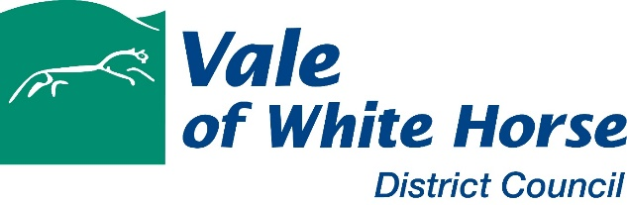

Application for Grant Funding – Affordable Housing
IMPORTANT
Please read guidance note before completing this form

Part 1 - Applicant
Organisation Name

Registered Address

RSH Registration Number (if applicable)

Contact Name

Telephone

Email

PART 2 – Project details
Scheme Name

Scheme Address

Planning Reference

Brief description of proposal (max 200 words)

Breakdown of proposed tenure and unit types
AFFORDABLE RENT | Number | Weekly Rent Payable | Equivalent Weekly Market Rent | Weekly Rent as % of Market Rent
1 bed
2 bed
3 bed
4 bed
Other (specify)

SOCIAL RENT | Number | Weekly Rent Payable | Equivalent Weekly Market Rent | Weekly Rent as % of Market Rent
1 bed
2 bed
3 bed
4 bed
Other (specify)

Low Cost Home Ownership | Number | Market Value | Initial Equity Share (%) | Sale price (should reflect Initial Equity Share %) | Rent payable on unsold equity (should not exceed 2.5%)
1 bed
2 bed
3 bed
4 bed
Other (specify)

General Needs
Yes |  | No

Supported
Yes |  | No

Other (please specify)

Will the project employ Modern Methods of Construction (MMC)? If Yes, please specify
Yes |  | No

Will the project be Low, Zero or Negative carbon? If Yes, please specify (max 200 words)
Yes |  | No

Please detail any further measures which will contribute to reducing the project’s carbon footprint (max 200 words)

Part 3 - Scheme costs and funding
Acquisition
Works (purchase cost if ‘off the shelf’)
On-costs
Total Scheme Costs (TSC)

Loan
RCGF
Other Public Subsidy (OPS) or Grants (specify below)
Initial sales income (LCHO only)
GRANT (requested in this application)
Total (should equal TSC)

OPS / Grants

Part 4 - Grant requested
 | Number of Units | Grant
Social Rent
Affordable Rent
Low Cost Home Ownership
TOTAL
Forecast Start on Site (M/Y)
Forecast Completion (M/Y)

Part 5 - Required documentation to be submitted with this application
- Financial Appraisal
- Layout and Location Plan
- Supporting statement
Signed |  | Name |  | Position

Date

PLEASE RETURN TO afforablehousingteam@southandvale.gov.uk no later than 6pm on 30 June 2021.

