Vale of White Horse District Council
Strategic Performance Report
Quarter 1 2021/22
August 2021

Contents
Background 3
Strategic Context 4
Theme 1. Providing the homes people need 5
Theme 2: Tackling the Climate Emergency 13
Theme 3: Building healthy communities 23
Theme 4: Building Stable Finances 34
Theme 5: Working in partnership 42
Theme 6: Working in an open and inclusive way 52
Covid-19 Response and recovery 61

Background
- The Council monitors performance and progress towards achieving the aims and priorities set out in the Corporate Plan.

- This report provides a strategic overview of performance for Q1 (1 April to 30 June 2021) focusing on the activity to deliver the corporate priorities in the Vale of White Horse Corporate Plan 2020-24.

- In addition to providing a performance update and assurance against the delivery of the Council’s six strategic themes in the Corporate Plan, this report will also provide any strategic context relevant to the Council’s operations and given the significant impact of Covid-19 on communities, services, and staff, the report will include a section on Covid-19 response and recovery.

- This report is the first iteration, and it is expected that it will evolve in line with the new approach to Performance Management being embedded in the Council as well as from feedback from senior officers and Members.

Strategic Context

The impacts of the Covid-19 pandemic continued to have far-reaching implications for the Council and our communities, during Quarter 1 – 01 April to 30 June 2021. Although the pandemic has created an unprecedented challenge for the Council, we have responded to the needs of our communities, whilst successfully starting to deliver on our commitments within the Vale of White Horse District Council Corporate Plan – a forward-looking plan which is the start of a new direction to 2024.
This Quarter included significant easing of restrictions as part of the Government’s roadmap steps 2 and 3, increasing many residents’ social freedoms. However, those who are clinically extremely vulnerable, or those who feel the level of risk is too high, have not been able to access these new social freedoms, which may create the risk of social isolation for some residents, with consequences for both mental and physical health. This Quarter has also seen the continuation of the biggest NHS vaccination programme in health service history, with half of adults over 30 having been vaccinated against Covid-19 by 27 June 2021, the impact of the pandemic on resident wellbeing remains a focus for the Council in Quarter 2 and beyond.
The national reopening of sports facilities, retail and hospitality sectors and cultural centres from 26 June and the reopening of the Beacon in Quarter 2 (formally used as a Covid-19 test centre), and potential income generation opportunities from projects to be delivered later in the Corporate Plan – such as the Strategic Property Review are both important aspects to building financial resilience. In addition, this Quarter the Council has responded to opportunities to influence HM Government for an improved financial settlement for councils, to ensure long term financial and service sustainability. We have submitted consultation responses on the future of the New Homes Bonus (which included proposals on a new funding formula), the outcome of which will be monitored over the upcoming Quarter.

Theme 1. Providing the homes people need

Strategic Lead – Suzanne Malcolm – Deputy Chief Executive – Place
We will:
- find ways to provide more genuinely affordable housing, including housing for social rent, to better provide for the needs of the Vale residents
- aim to provide a mix of tenures in each development to build sustainable homes in balanced and sustainable communities
- use our influence on decision makers, where the responsibility lies outside of Vale.

We will do this by:
- exploring and considering opportunities to bring forward the delivery of homes people can afford
- adopting a policy framework that ensures those homes could be delivered in a way that supports the environment and people living healthy lives.

Key Activities in Q1:
In order to deliver on our commitment to provide more genuinely affordable housing, work has commenced on the research and collation of data that will underpin the exploration of opportunities to expedite delivery of homes people can afford. We have been working with partners to investigate how to utilise Growth Deal funding and S106 commuted sums to provide more genuinely affordable housing.

£391,400 has been allocated from the newly approved and adopted S106 affordable housing funding application process and criteria which will enable the delivery of affordable homes.

An options appraisal is being carried out for additional mobile home berths or affordable housing within a mobile home park at Radley.

In order to influence decision makers that sit outside the Vale we have been exploring the creation of a council-owned holding company or vehicle with developers, other local authorities, and key agencies. This will enable us to deliver a wide range of regeneration and community benefits including housing, community facilities, land maintenance and health.
£391,400
OF S106 ALLOCATED TO DEVELOP AFFORDABLE HOMES

To further our ambition to provide a mix of tenures in each development to build sustainable homes in balanced and sustainable communities an updated Community Infrastructure Level spending strategy is now in place to accelerate the delivery of local infrastructural improvements. We have implemented systems to enable real time monitoring and reporting on income generation, spend and infrastructure projects. A workshop with Bioregional has been arranged for 14 July to showcase local examples lower-carbon construction and promote more sustainable ways of living across the Vale of White Horse.

Work has commenced on the research and collation of data that will feed into a refreshed housing policy. The policy will outline the types of housing, provide, the mix of design and for what demographic and tenure. It will also include affordable housing aspirations and environmental policies. This policy will inform our Local Plan and our work going forward.

We are using the Dalton Barracks Garden Villages and Towns designation as a mechanism to introduce innovative housing to meet our needs for high quality, low energy, zero-carbon homes. A Supplementary Planning Document (SPD) is being prepared to ensure a comprehensive approach to master-planning housing on the site. We have now included low and zero carbon as part of its S106 spend criteria to facilitate the construction of high-quality, sustainable housing in the area and have engaged with our councillors about challenges and further opportunities. To facilitate engagement with the project, a site walk was held with councillors to learn about the opportunities and challenges relating to the Dalton Barracks Garden Village. This engagement activity will be further enhanced by the formation of a ‘project board’ – this is also intended to improve governance arrangements.

To support the Councils’ commitment to deliver homes that support people living healthy lives, we have recently submitted a consortium bid into HM Government Levelling Up Fund for the B4044 cycle scheme and are working with partners to produce an Active Travel Network map of current and required coverage across the Vale.
Performance Measures
Corporate Plan ID | Stated Aim/Project description | Measure | Cabinet Lead | Officer Lead | Performance Update
PHPN1.1 | Programme 1 - Explore and consider opportunities to bring forward the delivery of homes people can afford | Narrative report of newly identified opportunities to bring forward/expedite the delivery of affordable homes | Cllr Judy Roberts | Chris Traill | Work has commenced on the research and collation of data that will underpin the report on newly identified opportunities to bring forward/expedite the delivery of affordable homes. In collaboration with partners (Registered Providers, community groups etc), the Council is also looking to identify and expedite the delivery of affordable housing through Growth Deal funding and the use of its own S106 commuted sums.
PHPN1.2 | Explore a council-owned holding company/vehicle, to focus on delivering a wide range of regeneration and community benefits including housing, community facilities, land maintenance and health | Narrative update on the potential opportunities/challenges around the creation of a holding company/SPV | Cllr Judy Roberts | Eliot Ward | The Vale have started preliminary discussions with developers, partners, and other local authorities about how the Council engages above the planning process. In addition, meetings have been held with several key agencies, including Homes England, Oxfordshire County Council and the Clinical Commissioning Group.
PHPN1.3 | Explore how the council can provide low-cost sustainable housing. Include working with developers, registered providers, community trusts, as well as new partnerships. Include council owned housing. Include a definition of affordability relative to ability to pay, not to market value, and social rent definitions | Narrative report on provision of low-cost housing, focusing on partnership working, including an update on the shifting metric of affordability based on relative ability to pay rather than market value and social rent definitions. | Cllr Judy Roberts | Chris Traill | No progress reported Q1 2021/22
PHPN1.4 | Review our affordable housing planning policies and ensure they are providing what's  needed in the Vale | Narrative report on review of planning policies | Cllr Judy Roberts | Chris Traill | No progress reported Q1 2021/22

Performance Measures
Corporate Plan ID | Stated Aim/Project description | Measure | Cabinet Lead | Officer Lead | Performance Update
PHPN1.5 | Review our strategy for spending s106 sums paid in lieu of onsite affordable housing and identify how earmarked funds, including retained S106 monies, can be best utilised to deliver affordable homes | Narrative report on s106 spend, focusing on the stated aim and any updates to the existing strategy  Additional quantitative elements - s106 spend/units provided from spend | Cllr Judy Roberts | Chris Traill | A S106 affordable housing funding and application process and spend criteria has been approved by the council. £391,400 was allocated during Q1 2021/22.
PHPN1.6 | Explore how mobile homes might be better used as affordable homes, reviewing sites and policies to ensure good use of available space | Narrative update on utilisation of mobile homes/mobile home sites or opportunities for creating such sites | Cllr Judy Roberts | Chris Traill | An options appraisal is being carried out for additional mobile home berths as affordable housing within a mobile home park at Radley. More generally, it must be noted that Registered Providers do not consider mobile homes to be viable as affordable housing.
PHPN1.7 | Use Garden Villages and Towns designation as a mechanism to introduce innovative housing to meet our needs for high quality, low energy, zero-carbon homes | Narrative report on garden village and town designation utilisation and any projects which fall within this designation. Also, to include initiatives which will result in low energy, zero carbon homes. | Cllr Judy Roberts | Chris Traill | To facilitate engagement with the project, a site walk was held with councillors where could learn about the opportunities and challenges relating to the Dalton Barracks Garden Village. This engagement activity will be further enhanced by the formation of a ‘project board’ – this is also intended to improve governance arrangements.  A Supplementary Planning Document (SPD) for Dalton Barracks is currently being prepared by the Planning Team with input from Development and Regeneration. This will ensure a comprehensive approach to master-planning housing on the site, as well as guaranteeing that Garden Village principles are adhered to. In addition, the Council has included low and zero carbon as part of its S106 spend criteria to facilitate the construction of high-quality, sustainable housing.
Performance Measures
Corporate Plan ID | Stated Aim/Project description | Measure | Cabinet Lead | Officer Lead | Performance Update
PHPN2.1 | Programme 2 - Adopt a policy framework that ensures those homes could be delivered in a way that supports the environment and people living healthy lives | Narrative report against the Programme aim | Cllr Judy Roberts | Chris Traill | No progress reported in Q1 cycle 2021/22
PHPN2.2 | Develop a s106 obligations strategy to inform negotiations between planners and developers | Narrative report on strategy development/adherence (once delivered) | Cllr Judy Roberts | Adrian Duffield | No progress reported Q1 2021/22
PHPN2.3 | Update the CIL spending strategy and associated procedures to accelerate the delivery of local infrastructural improvements for our communities both in line with our corporate objectives and, where appropriate, to support current spending on existing infrastructure | Narrative update on CIL spend to support the delivery of local infrastructure  Total CIL spend + CIL spend breakdown | Cllr Judy Roberts | Chris Traill | An updated CIL spending strategy came into effect on 1 April 2021. This strategy includes the option for an annual review if required.  While reporting on income, spend and projects can be requested at any time, cabinet members are, as a matter of course, provided with quarterly CIL and S106 spend/income reports. In addition, a statutory infrastructure funding statement – covering sums received, spent and their intended use – will be published by December each year.
PHPN2.4 | Consider ways we can encourage lower-carbon construction in Vale | Narrative update to include any activity supporting lower-carbon construction in the Vale | Cllr Catherine Webber | Chris Traill | The Economic Development team have arranged a ‘Sustainable Construction’ workshop to be held on 14 July 2021. This is intended to showcase local examples of lower-carbon construction, as well as providing an opportunity for attendees to hear from Bioregional – a charity and social enterprise committed to developing more sustainable ways of living.

Performance Measures
Corporate Plan ID | Stated Aim/Project description | Measure | Cabinet Lead | Officer Lead | Performance Update
PHPN2.5 | Develop an affordable housing SPD. Evidence of housing needs, housing mix, self-build, rural exception sites. Include definition of 'affordable' | Narrative update on the development of an affordable housing SPD, additionally include information on planning permissions granted with affordable housing numbers | Cllr Judy Roberts | Adrian Duffield | No progress reported Q1 2021/22
PHPN2.6 | Develop a Land Use strategy to inform and guide OxPlan2050 and Vale Local Plan with proposed need for housing, retail, employment, leisure, open spaces | Narrative update on progression against stated aim of PHPN 2.6 in the corporate plan. | Cllr Judy Roberts | Adrian Duffield | Annual Target - No response submitted Q1 2021/22
PHPN2.7 | Update the Local Development Plan to reflect the Oxfordshire Infrastructure Strategy (OxIS) and connecting our strategic housing sites with employment land | Narrative update on progression against stated aim of PHPN 2.7 in the corporate plan. | Cllr Judy Roberts | Adrian Duffield | Annual Target - No response submitted Q1 2021/22
PHPN2.8 | Update Vale’s Local Plan and OxPlan2050 with modern environmental policies in support of government's and Vale's goals | Narrative update on progression against stated aim of PHPN 2.8 in the corporate plan. | Cllr Debby Hallett | Adrian Duffield | Annual Target - No response submitted Q1 2021/22

Performance Measures
Corporate Plan ID | Stated Aim/Project description | Measure | Cabinet Lead | Officer Lead | Performance Update
PHPN2.9 | Develop a Housing Policy: that outlines the types of housing we are going to provide, in what mix of design and for what demographic and tenure, to inform our Local Plan and future work. Include affordable housing aspirations, consideration of an aging  population, and environmental policies for housing | Narrative update on housing policy and adherence.  Include quantitative measures for housing mix, tenure, and affordable and shared ownership. | Cllr Judy Roberts | Chris Traill | Work has commenced on the research and collation of data that will feed into the report on housing policy. The Vale (in collaboration with Registered Providers, community groups and others) are also in the process of identifying and expediting the delivery of affordable housing opportunities through Growth Deal funding and S106 commuted sums.
PHPN2.10 | Work with partners to produce an Active Travel Network map of current and required coverage across the Vale to include commercial and community buses, cycle paths and storage facilities, pavements and footpaths, green and blue infrastructure, and local taxi firms. Encourage systems that increase use of the Active Travel Network | Narrative update on progress toward completion of map, once map completed, this should transition to an annual review of the accuracy of map | Cllr Judy Roberts | Chris Traill | The facilitation of Active Travel is predominantly a County function. Officers are, and will, work with their colleagues at Oxfordshire County Council to encourage cycling, walking and other alternatives to the car. A recent example of this work is the submission of a bid for Levelling Up Fund Resources for cycle routes on the B4044.

Theme 2: Tackling the Climate Emergency

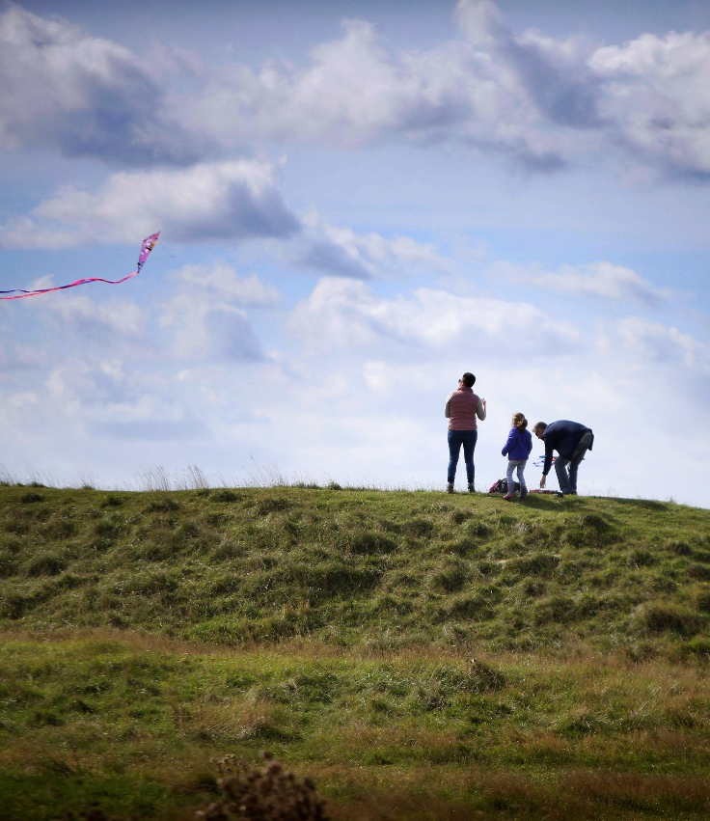
Strategic Lead – Suzanne Malcolm – Deputy Chief Executive – Place

We will:
- do everything we can to help tackle the Climate Emergency
- reduce council emissions by 75% by 2025
- become a carbon neutral council by 2030
- reduce all emissions across the Vale District by 75% by 2030
- aspire to be a carbon neutral Vale district by 2045.

We will do this with:
- a Climate Emergency programme, focussed on what the council has control over, working towards our own targets for our own buildings, vehicles, leisure and arts centres
- a Climate Emergency programme focussed on encouraging the wider district community to reduce its carbon footprint in order to meet the Climate Emergency targets
- a programme around exercising our influence with partners on wider policy, working with neighbouring authorities, lobbying Government, and identifying environmental policy gaps.

Key Activities in Q1:
Working to reduce carbon emissions from our own operations including our buildings is an important part of our work tackling the climate emergency. During Quarter 1 the Vale secured £361,000 of external funding from the Public Sector Decarbonisation Scheme to fully refurbish the heating system at Faringdon Leisure Centre with the installation of a low carbon, renewable energy system. A Project Manager has been appointed to coordinate the delivery of these improvements and the initial stages of the tendering process are underway. The works are on track for completion in 2022.

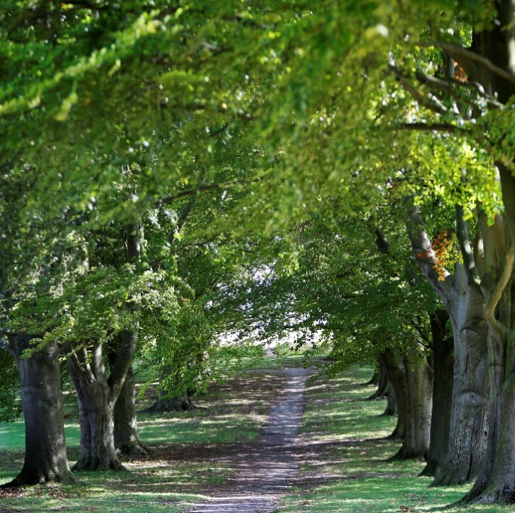
The design process for the new Council shared office is also well underway, with the minimisation of carbon emissions a key part of the brief. The building is being designed to achieve ‘BREEAM excellent’ accreditation and deliver a strong performance in terms of carbon emissions- 40% lower than those stipulated in the 2013 building regulations. Furthermore, provision has been made so that the embedded carbon in the building fabric as well as emissions from day-to-day operations will be calculated to facilitate offsetting.

With the aim of increasing tree cover and improving biodiversity in the district, development of the policy for planting trees on Council land is underway. Sites are currently being explored by the Property team drawing on insights from the Strategic Property Review.

As part of our work to encourage the wider district community to reduce their carbon footprint, the climate action pages of the council website have been revamped and now include up to date information on how residents can play their part, including in cutting carbon emissions from their home.

The Council has also joined the Oxfordshire Greentech network. The network can provide be valuable resource for businesses as they seek to reduce their carbon footprint.
£361,000

EXTERNAL FUNDING SECURED TO REFURBISH HEATING SYSTEM AT FARINGDON LEISURE CENTRE

The Air Quality Annual Status Report to Defra was submitted on 30 June 2021. To achieve our aim of improving how we measure air quality, Environmental Protection are working to determine where a Particulate Matter (PM) monitor would best be located. Vale has £16,500 in capital funding available for this project. The Government’s forthcoming ‘Environment Bill may well introduce a requirement to monitor PMs and include specific requirements around the specification and location of equipment and the Council is acting with this in mind.

Throughout Quarter 1, the Climate Action Team have worked with colleagues across council departments to ensure that our commitments on the climate emergency are reflected in the work we do. The team have reviewed plans, provided insight and expertise, and advised colleagues on how projects can be made as climate friendly as possible, with all formal reports now having a “climate implications” section. This engagement with teams across the council has contributed to ‘tackling the climate emergency’ being such an important factor across several themes in this report. It also reflects the fact that action on climate change must be wide ranging if we are to meet the scope of our ambition in this area.

The council is moving forward in the development of the Climate Action Plan and will be co-creating the plan with service areas to ensure the Climate Emergency is fully embedded into all service plans.
Performance Measures
Corporate Plan ID | Stated Aim/Project description | Measure | Cabinet Lead | Officer Lead | Performance Update
PROGRAMME 1 | A climate emergency programme, focussed on what the council has control over, working towards our own targets for our own buildings, vehicles, leisure and arts centres | A narrative summary comprised of all new activity to reduce the carbon footprint of all Council assets on a quarterly basis |  | Harry Barrington-Mountford | The new shared office – located in South Oxfordshire – is being designed to both achieve BREEAM (the world’s leading sustainability assessment method for master planning buildings) excellent accreditation and a greater than 40% reduction in carbon reductions from those contained within the 2013 building regulations. The embedded carbon in the building fabric and emissions from day-to-day operations will be calculated to facilitate offsetting as part of a wider corporate approach to climate change.  The Vale has also successfully secured £361k of external funding from the Public Sector Decarbonisation Scheme for the installation of low carbon and renewable energy at Faringdon Leisure Centre. This will involve the full refurbishment of the heating system on both the wet and dry sides of the centre. A Project Manager has been appointed to coordinate the delivery of these improvements and the initial stages of the tendering process are already underway. The works are due for completion in 2022.
TCE1.1 | Develop a Climate Emergency Strategy for the Council, setting out how we will reach Zero Carbon for all Vale assets by 2030. Identify energy saving opportunities in council-owned buildings and fleets | A narrative report of activity underway to design the plan to achieve a zero-carbon position for all Vale assets by 2030. | Cllr Catherine Webber | Harry Barrington-Mountford | A Climate Action Plan for the Vale is being developed. A tool (GlidePath) to measure the reduction in carbon emissions has also been implemented.  The consideration of further opportunities to identify energy saving opportunities in council-owned buildings will be based on the recommendations arising from the Strategic Property Review.
TCE1.2 | Complete the CEAC Year One Climate Action Plan and plan for future years | Narrative report on progress | Cllr Catherine Webber | Harry Barrington-Mountford | A Climate Action Plan is being developed for the Vale.

Performance Measures
Corporate Plan ID | Stated Aim/Project description | Measure | Cabinet Lead | Officer Lead | Performance Update
TCE1.3 | Include in Councils Open Space Strategy opportunities to increase biodiversity, increase tree cover, and (other things we want to do on Council's open spaces) | Narrative report on specific opportunities which have arisen for the council to improve open spaces. Also include any additional policy developments. | Cllr Catherine Webber | Harry Barrington-Mountford | A policy for the planting of trees on Council land is currently being developed. Sites are currently being explored by the Property team (based on the findings of the Strategic Property Review).
PROGRAMME 2 | A climate emergency programme focussed on encouraging the wider district community to reduce its carbon footprint in order to meet the Climate Emergency targets | A narrative update of the work of the comms team in promoting measures/initiatives which will help the community to reduce it's carbon footprint. |  | Harry Barrington-Mountford | The Vale website has been refreshed to contain advice on how residents can reduce their carbon footprint (Action on Climate and Nature). Additional information on how to decrease emissions from domestic properties has also been made available.  The Council has joined the Greentech network. This helps support businesses in lessening their impact upon the environment.
TCE2.1 | Complete those tasks in Year one Climate Action Plan that have to do with reducing carbon in the wider district | Narrative report on progress | Cllr Catherine Webber | Harry Barrington-Mountford | A Climate Action Plan for the Vale is being developed. The focus this quarter has, nevertheless, been on work to reduce the carbon footprint of the council’s own assets – as this is within our direct control – rather than the wider district.
TCE2.2 | Introduce policies for zero carbon construction requirements | Narrative update on progress toward design guide implementation, transitioning into review of relevant information/developments in this area | Cllr Catherine Webber | Adrian Duffield | A Joint Design Guide (JDG) Supplementary Planning Document is currently being produced. This will contain guidance on zero carbon in construction. The JDG is due for internal consultation in August and external consultation in October. The final draft is then scheduled to be ready in December with it being adopted in February 2022.

Performance Measures
Corporate Plan ID |  | Stated Aim/Project description | Measure | Cabinet Lead |  | Officer Lead | Performance Update
TCE2.3 |  | Introduce sustainable growth and environmental policies to our Local Plan | Narrative update on the progress towards development of new local plan, specifically referring to details in TCE2.3/4 | Cllr Catherine Webber |  | Adrian Duffield | Annual Target - No response submitted Q1 2021/22
TCE2.4 |  | Ensure our Local Plan contains polices to make new buildings carbon zero to build and to live/work in | Narrative update on the progress towards development of new local plan, specifically referring to details in TCE2.3/4 | Cllr Catherine Webber |  | Adrian Duffield | Annual Target - No response submitted Q1 2021/22
TCE2.5 | Develop a year two plan with CEAC for meeting our Climate emergency goals |  | High level narrative on progress towards approval of two-year plan |  | Cllr Catherine Webber | Harry Barrington-Mountford | The Climate Action Plan for the Vale is being developed this will set out actions towards the climate emergency until 2024.
TCE2.6 | Improve how we measure air quality. Explore particulate measurement in our sensitive areas. Explore ways to publish AQ measurements in live time, so people can make decisions on whether it's healthy outside for them today |  | Narrative containing updates/changes to AQ monitoring techniques, an update on work with partners to monitor AQ and details of published AQ measures |  | Cllr Catherine Webber | Liz Hayden | The Vale has £16,500 one-off capital funding available for 2021/22. The Environmental Protection team are, therefore, considering where a particulate matter (PM) monitor could be installed that could provide base line data.  HM Government may also introduce a requirement to monitor PM as part of the measures contained within their Environment Bill. If this occurs, we anticipate that Defra may offer some form of grant funding to local authorities for the purchase of additional PM monitors and equipment. They would also be expected to provide technical guidance relating to monitoring locations, equipment sensitivity etc.

Performance measures
Corporate Plan ID | Stated Aim/Project description | Measure | Cabinet Lead | Officer Lead | Performance Update
TCE2.7 | Update the Air Quality Action Plans for our Air Quality Management Areas | Until funding confirmed for development of new AQAP's, narrative update on any significant deviation from last relevant AQAP. Once funding confirmed, this can report on the development of the new AQAP. | Cllr Catherine Webber | Liz Hayden | The Air Quality Annual Status Reports have been submitted to Defra. These were due on 30 June 2021.  A By the end of August internal processes will commence to seek funding for the development of new Air Quality Action Plans.
TCE2.8 | Explore setting up a Habitat Bank to deliver biodiversity offsetting requirements and facilitate tree planting | Narrative update as to progress of potential pilot and other relevant initiatives | Cllr Catherine Webber | Harry Barrington-Mountford | South and Vale in partnership with the Berkshire, Buckinghamshire & Oxfordshire Wildlife Trust (BBOWT) and Finance Earth are attempting to set up a Habitat Banking Pilot Scheme. To further this work, the Councils have supported an application to Defra’s Natural Environment Readiness Fund for the establishment of two habitat restoration projects (one in each district). We are currently awaiting the outcome of this bid.
PROGRAMME 3 | A programme around exercising our influence with partners on wider policy, working with neighbouring authorities, lobbying Government and identifying environmental policy gaps | General Narrative update |  | Harry Barrington-Mountford | Successful Town and Parish Forums focusing on climate action took place during Q1 2021/22. These events were well attended and several key themes relating to the both the climate emergency and Climate Action Plan were discussed.

Performance Measures
Corporate Plan ID | Stated Aim/Project description | Measure | Cabinet Lead | Officer Lead | Performance Update
TCE3.1 | Complete the CEAC Year One Action Plan and plan for future years | Narrative report on progress | Cllr Catherine Webber | Harry Barrington-Mountford | A Climate Action Plan for the Vale is being developed. Alongside the continued delivery of actions from the CEAC year one work programme.
TCE3.2 | Work with partners to define a waste reduction scheme: including ways to reduce bulky waste headed to landfill and reduce recycling contamination | Narrative report to outline steps to influence partners and our actions to reduce overall waste | Cllr Catherine Webber | Liz Hayden | The Vale continues to work with Biffa to consistently send good quality recycling to the sorting depot. Contamination rates are approximately 9 per cent which is low when compared to other local authorities.  In order to further reduce overall waste, we have launched a new webpage “reducing your waste and increasing your reuse” – https://www.whitehorsedc.gov.uk/vale-of-white-horse-district-council/recycling-rubbish-and-waste/reducing-your-waste-increasing-your-reuse/  This outlines some of the actions that residents can take to reduce consumption and increase recycling.  While bulky waste levels are currently less than 5 per cent, the Council continues to collaborate with partners to further reduce the amount heading for landfill.
TCE3.3 | Develop a tree-planting strategy and work with partners to plant more trees across the district | Narrative update to include development of the tree policy and subsequent activity | Cllr Catherine Webber | Harry Barrington-Mountford | A Tree policy is currently being developed.

Performance Measures
Corporate Plan ID | Stated Aim/Project description | Measure | Cabinet Lead | Officer Lead | Performance Update
TCE3.4 | Develop a Biodiversity Net Gain Targeting Strategy and contribute to a Nature Recovery Network for Oxfordshire | Narrative update on related work, including but not limited to the work to support the Oxfordshire Plan. | Cllr Catherine Webber | Adrian Duffield | No progress reported Q1 2021/22
TCE3.5 | Work with partners to provide electric charging points in Vale car parks and at our buildings, and increase charging infrastructure across Oxfordshire | A narrative update to include work to promote and develop EV infrastructure across the district.  Quantitative element - breakdown of existing/planned EV charging points | Cllr Catherine Webber | Liz Hayden | The EV ‘Park and Charge’ project is being managed by Technical Services. Following the completion of due diligence on phase one, the next stage is to meet the electricity supplier – when appointed by Zeta/EZ – to discuss and agree the layout and design of bays. The aim is to complete the installation of EV charge points by March 2022.  e.
TCE3.6 | Take an active role in the Oxford-Cambridge arc to influence the inclusion of sustainable growth and environmental policies | A narrative update on the work of the Oxford-Cambridge arc and our influencing activity | Cllr Catherine Webber | Adrian Duffield | As part of the work being undertaken to develop the Oxfordshire Plan 2050, officers are influencing the development of the Arc Spatial Framework. In addition, they have also attended several meetings (e.g. the Arc Collaboration Forum early-stage workshop) that will help to influence and shape the future development of the arc.  Officers have also, in collaboration with their colleagues at Oxfordshire County Council, succeeded in changing the parameters of England’s Economic Heartland’s Oxford-Milton Keynes transport study. It will now cover a new wider area which will include Science Vale.  Lead members of the Council are also engaging with the Oxford to Cambridge Arc through a variety of channels (e.g., the Arc Leaders Group). Furthermore, in April, Vale Cabinet endorsed the Arc Environmental Principles. These set out how the Arc partners will seek to: work towards a target of net zero carbon at an Arc level by 2040; protect, restore, enhance, and create new nature areas and natural capital assets; be an exemplar for environmentally sustainable development; ensure that existing and new communities see real benefits from living in the Arc; and use natural resources wisely.
Performance Measures
Corporate Plan ID | Stated Aim/Project description | Measure | Cabinet Lead | Officer Lead | Performance Update
TCE3.7 | Take an active role in the Growth Deal and the Oxfordshire Plan 2050 to influence the inclusion of sustainable growth and environmental policies | Narrative report on work to support the Oxfordshire Plan in accordance with TEC3.7 | Cllr Catherine Webber | Adrian Duffield | Annual Target - No response submitted Q1 2021/22
TCE3.8 | Work with local partners and Government to encourage retrofitting houses with sustainable energy schemes; help residents take advantage of schemes that come along to help with costs | Narrative report on work influencing work, comms activity and direct engagement with residents. | Cllr Catherine Webber | Harry Barrington-Mountford | A joint retrofit task and finish group was set up to review the retrofit landscape across both districts and to make recommendations for a way forward with this work. The group met with key partners to understand their experiences and perspective on retrofit. A report was written, summarising the key points raised during the meetings, as well as recommended ways forward to address the retrofit needs in the districts. Councillors are currently working on a more detailed report that will be shared more widely.

Theme 3: Building healthy communities

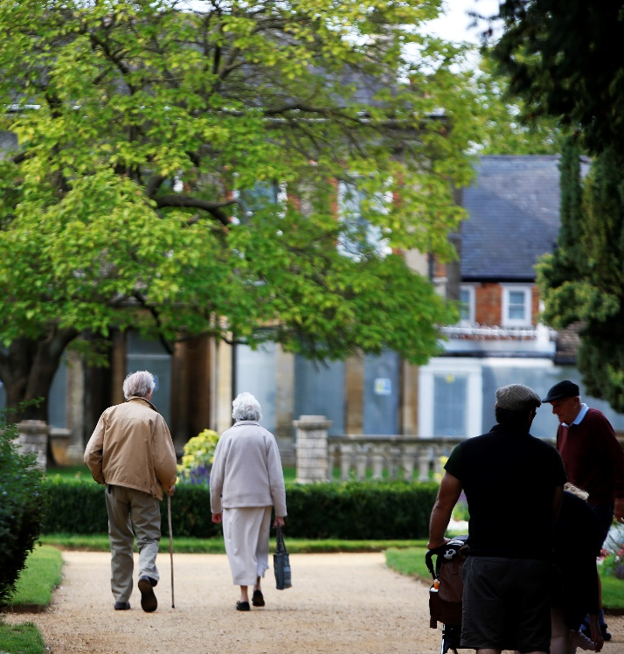
Strategic Lead – Adrianna Partridge – Deputy Chief Executive – Transformation and Operations

We will:
- contribute to making people’s lives healthier by encouraging the switch to more active travel, improving air quality where people work and live, and providing active opportunities.

We will do this by:
- building strong communities and connections with a sense of place and strong community identity
- promoting healthy place shaping and active communities for everyone
- safeguarding and supporting our vulnerable residents

Key Activities in Q1:
In order to deliver our aim to build strong communities and connections with a sense of place, we have embedded this approach within our master plan for our new offices at Didcot Gateway. Consideration is being given to the ideas of connectivity and public realm. Being situated in a major population centre with good bus links, and adjacent to a main line rail station, makes the proposed location particularly sustainable in travel terms.

We have undertaken a Strategic Property Review (SPR) on the use of community buildings, land and other facilities owned or managed by the council. This is designed to ensure that communities have spaces in which to come together and that we are maximising their usage – and consequently income. The Review’s findings will be considered by Vale Cabinet in October and will be followed by a study on our future property requirements.
A meeting has been scheduled between officers and the relevant Cabinet member to initiate the development of a Public Arts policy for the district. This will be underpinned by the development of a strategy to support its delivery.

To deliver on our commitment of promoting healthy place shaping and active communities for everyone, an overview of what the new Active Communities Strategy could include has been developed. The strategy will outline how the council will work with our communities and partners to enable everyone to participate in physical activities. We will consider the Covid-19 System Roadmap and other regional and national health and wellbeing priorities when defining its scope. To help further this work, the Vale have engaged a consultant to deliver a Sport England Strategic Options Planning Guidance report. This is the first step to understanding the current state of our council owned/operated facilities.

Through our work with Active Oxfordshire, we are running Get Active projects targeting our most deprived communities Sport England, through Active Oxfordshire, fund an Active Reach partnership project in Abingdon. Community groups and charities can apply to receive £10,000 to support interventions that assist socio-economically disadvantaged families and isolated individuals within areas suffering from high levels of deprivation. Phase 3 of the project aims to tackle the isolation and loneliness of vulnerable older people. It is anticipated that this will help to improve their mental and physical wellbeing. An Active Reach programme is scheduled to run in Faringdon during Q2 2021/22.

We are setting up a 'Ride Revolution' pilot in Abingdon to help residents learn how to ride a bike and provide them with access to equipment and free cycling tuition where needed.

Our councillors are working with partners to address key strategic health and wellbeing issues across Oxfordshire. During Q1, two meetings of the Health Overview and Scrutiny Committee and one Health Improvement Board meeting were held to consider these matters.
A new planning policy on air pollution is being developed through the Oxfordshire Plan 2050. The preferred approach is for the Plan to provide a strategic planning framework which will not only protect air quality by setting minimum county-wide standards, but also provide a structure for improving air quality wherever possible.
11
SAFEGUARDING REFERRALS FOR VULNERABLE RESIDENTS

In addition, the Vale have submitted the latest Air Quality Annual Status Reports to Defra and during Q2 2021/22, a project GW2 form to seek funding for the development of new Air Quality Action Plans. We are also continuing to use the planning regime as a tool to improve air quality by publishing updated Air Quality Guidance for Developers. This outlines the supporting information that they must provide to assess the potential impacts of their proposed activities on air quality. It also summarises the best practice design features that are expected for new development e.g. EV charging points.

Neighbourhood Plans also provide an opportunity for communities to develop policy related to air quality. There are currently 12 adopted (made) Neighbourhood Plans in Vale, with a further 3 progressing through the formal stages to adoption. 8 more neighbourhood plans are also in progress but at earlier stages.

The Council has also launched the third stage of the Turn it Off campaign to target poor air quality at school gates by raising awareness of the issue and promoting alternative, sustainable means of travel.

To further our commitment to safeguard and support our vulnerable residents, all staff are required to undertake safeguarding training and be “professionally curious” when conducting their duties. During Q1 2021/22 there were 11 safeguarding referrals. 20 closure orders were made in 2020/21 to protect the most vulnerable members of the community. Closure orders are intended to target those premises that could be considered ‘high risk’ and where there is evidence of exploitative or coercive practice or the involvement of children.

Our community hub has been a real success of the Covid-19 pandemic, with council resource and community partners working closely together to deliver support for residents (particularly those with vulnerabilities). The councils’ recovery plans will include mapping the future need and delivery model going forward. This will complement work being undertaken at the county level to develop a Systems Recovery Framework.

We recently adopted the Oxfordshire’s Homelessness and Rough Sleeping Strategy, this prioritises homelessness prevention, rapid response, ensuring the right home in the right place and a person-centred approach to homelessness. Moreover, the second phase of the South and Vale Housing First project is nearly complete. This project aims to take entrenched rough sleepers off the streets by offering them intensive, tailored and open-ended support without any preconditions.

The South and Vale Community Safety Partnership works to agreed priorities: tackling domestic abuse; exploitation of vulnerable people and children (including modern slavery, county lines); and reducing knife crime, harm and vulnerability caused by drugs and alcohol. The Partnership supports the co-ordination of a sanctuary scheme to help vulnerable victims of crime stay and feel safe in their homes. 60 referrals were received to the scheme during 2020/21. Funding is provided to the Oxfordshire Domestic Abuse Service to deliver outreach and support for those whose lives have been disrupted by domestic abuse. The service received 1,757 calls to their hotline, during 2020/21, 406 of which were from residents of South and Vale and 232 clients were referred for outreach support. 49 clients in the Vale were judged to be high risk victims of domestic abuse and were supported by Independent Domestic Violence Advisors. The council’s Community Safety Team have continued to run monthly virtual Joint Task Meetings with partners throughout last year. This has enabled the maximisation of resources, knowledge, and data by partners to help support vulnerable individuals and those with complex needs.

A revised joint taxi policy has been implemented and officers are providing advice to existing drivers of any changes when applying for renewal. We are also currently reviewing the tariff for taxi licences in the Vale which will include a consultation with licensed drivers.

Performance Measures
Corporate Plan ID | Stated Aim/Project description | Measure | Cabinet Lead | Officer Lead | Performance Update
PROGRAMME 1 | Building strong communities and connections, with a sense of place and strong community identity | Narrative update |  | Harry Barrington-Mountford | The location for the new shared office is being master planned to ensure a strong sense of place. Consideration is being given to the ideas of connectivity and public realm. Being situated in a major population centre with good bus links, and adjacent to a main line rail station, makes the proposed location particularly sustainable in travel terms.
BHC1.1 | Review the use of Community buildings and other facilities owned or managed by the council to maximise usage, income for the council and ensure communities have spaces in which to come together. | Narrative update as to the progress/outcomes from the Strategic Property Review | Cllr Helen Pighills | Chris Traill | The Strategic Property Review (SPR) has been completed. Its findings will be considered by Vale Cabinet in October. The next stage is for a study to be undertaken of the Council’s future property requirements.
BHC1.2 | Establish a Public Arts policy | Narrative update on the progress towards developing a public arts policy | Cllr Helen Pighills | James Carpenter | A meeting has been scheduled between officers and the Cabinet member to consider this matter. This will map out the way forward for public art within the Vale. A strategy will be developed to support this.
BHC1.3 | Maintain and develop the council’s Community Enablement function to respond to changing needs because of Covid-19 | Narrative update on relevant areas of the Council response to Covid 19 as the needs/requirements change | Cllr Helen Pighills | James Carpenter | The community hub has continued to support members of the public during Q1 2021/22. The Council’s recovery plan from the Covid-19 pandemic will assess the best delivery model for supporting residents as we move forward. This work will include mapping the future need for the services provided by the community hub. In the interim, the Vale has, and continues to support staff redeployed into this area.

Performance Measures
Corporate Plan ID | Stated Aim/Project description | Measure | Cabinet Lead | Officer Lead | Performance Update
BHC1.4 | Work with others to promote Active Travel and support the development of Local Cycling and Walking Infrastructure plans to help shape new developments that link homes to work, recreation and social spaces within communities | Narrative report on the work with partners to promote active travel and encouragement of cycling and walking infrastructure  Quantitative measure of amount of new footpaths/cycle paths approved since last report/YTD etc. | Cllr Helen Pighills | Chris Traill | The Council is working with several partners (Active Oxfordshire, Sovereign, Abingdon and Witney College, Trax and Larkmead School) to set up a ‘Ride Revolution’ pilot in Abingdon. This will help residents to learn how to ride a bike and provide them with access to equipment and free cycling tuition.
BHC1.5 | Develop planning policies to ensure careful consideration of the effect of air pollution on the lives of people who will live there | Narrative update to include information relevant to BHC 5.1,  Quantitative measure - the number of neighbourhood plans and the stage they are current at | Cllr Catherine Webber | Adrian Duffield | A new planning policy on air pollution is being developed through the Oxfordshire Plan 2050. The preferred approach is for the Plan to provide a strategic planning framework which will not only protect air quality by setting minimum county-wide standards, but also provide a structure for improving air quality wherever possible. The Joint Local Plan between the Vale and South Oxfordshire could also be used to provide further details regarding air quality where appropriate.  Neighbourhood Plans also provide an opportunity for communities to develop policy related to air quality. There are currently 12 adopted (made) Neighbourhood Plans in Vale, with a further 3 progressing through the formal stages to adoption. 8 more neighbourhood plans are also in progress but at earlier stages.

Performance Measures
Corporate Plan ID | Stated Aim/Project description | Measure | Cabinet Lead | Officer Lead | Performance Update
BHC1.6 | Update the Air Quality Management Action Plans for the Vale’s air pollution hotspots; Work with Oxfordshire County Council to improve how we measure and report air pollution and how we will work with schools and community groups to raise awareness of our clean air campaigns | Narrative update on activity related to BHC 1.6 | Cllr Catherine Webber | Liz Hayden | The Air Quality Annual Status Reports have been submitted to Defra. These were due on 30 June 2021.  In addition, the Vale continues to use the planning regime as a tool to improve air quality by publishing updated Air Quality Guidance for Developers. This outlines the supporting information that they must provide to assess the potential impacts of their proposed activities on air quality. It also summarises the best practice design features that are expected for new development e.g. EV charging points.  The Council has also launched the third stage of the Turn it Off campaign. This targets poor air quality at school gates by raising awareness of the issue and promoting alternative, sustainable means of travel.  In collaboration with the other local authorities in Oxfordshire, the Vale submitted a successful bid to Defra’s Air Quality Grant Programme to fund the updating of the current Oxfordshire Air Quality Website – https://oxfordshire.air-quality.info/. This project is now a priority for the six councils involved.
PROGRAMME 2 | Promoting healthy place shaping and active communities, for everyone | Narrative update |  | Harry Barrington-Mountford | Council Officers are now attending the county-wide Healthy Place Shaping Steering Group (two meetings of which have been held). A shared resource between the Oxfordshire councils is in place for Healthy Place shaping, joining the Vale from January 2022 to further develop this work in our district.  The Vale is also involved in the county-wide Move Together programme. This provides personalised support for both people who are clinically extremely vulnerable and residents whose health has been affected by the lockdowns of the past year.

Performance Measures
Corporate Plan ID | Stated Aim/Project description | Measure | Cabinet Lead | Officer Lead | Performance Update
BHC2.1 | Produce an Active Communities strategy; setting out how the council will work with our communities and partners and enable everyone to participate in physical activities | Narrative update on progress against strategy development and work with partners to encourage involvement in physical activities | Cllr Helen Pighills | Chris Traill | A consultant has been engaged to deliver a Sport England Strategic Options Planning Guidance report. This is the first step to understanding the current state of the council owned/operated facilities.  A drafted overview of the structure of the Active Communities Strategy has been created which will be considered alongside the Covid-19 System Roadmap and other regional and national health and wellbeing priorities to define the scope of the strategy.
BHC2.2 | Work with Active Oxfordshire to target get active projects in our most deprived communities | Narrative update on proposals form Active Oxfordshire | Cllr Helen Pighills | Chris Traill | Sport England, through Active Oxfordshire, fund an Active Reach partnership project in Abingdon. Community groups and charities can apply to receive £10,000 to support interventions that assist vulnerable, socio-economically disadvantaged families and isolated individuals within areas suffering from high levels of deprivation. Phase 3 of the project aims to tackle isolation and loneliness of vulnerable older people. It is hoped that this will help to improve their mental and physical wellbeing.  An Active Reach programme is scheduled to run in Faringdon during Q2 2021/22.
BHC2.3 | Promote use of the Council’s public green spaces for exercise and activity | Narrative update on the work to promote green spaces for exercise and activity | Cllr Helen Pighills | James Carpenter | No progress reported Q1 2021/22
BHC2.4 | Identify councils owned land for community gardening and allotments projects | Narrative update on the work/outcomes from the Strategic Property Review | Cllr Helen Pighills | Chris Traill | Surplus land for the creation of community gardens and allotments has been identified as part of the Strategic Property Review. The Council will commence working with local community groups in the near future to help deliver these projects.
Performance Measures
Corporate Plan ID | Stated Aim/Project description | Measure | Cabinet Lead | Officer Lead | Performance Update
BHC2.5 | Active engagement with the Oxfordshire Health Improvement Board and Health Overview and Scrutiny Committee to ensure the Vale has strong representation in countywide health forums | Narrative update on work with the Oxfordshire Health Improvement Board/Health overview and Scrutiny Committee | Cllr Helen Pighills | Harry Barrington-Mountford | The Vale is represented on both the Health Overview and Scrutiny Committee and the Health Improvement Board. During Q1 2021/22, there were two meetings of the Health Overview and Scrutiny Committee and one of the Health Improvement Board. These considered several matters including Oxfordshire’s continuing response to the Covid-19 pandemic and the county’s performance against the measures outlined in the Joint Health and Wellbeing Strategy.  Work is now also being undertaken at the county level to develop a Systems Recovery Framework.
PROGRAMME 3 | Safeguarding and supporting our vulnerable residents | Narrative report on support provided by the VCS and potentially the number of properties approved with special adaptations (drawn from AMR data, available annually) |  | Liz Hayden | All Vale staff receive safeguarding training as a matter of course. They are required to be “professionally curious” when conducting their duties.  During Q1 2021/22 there were 11 safeguarding referrals.  In total, 20 closure orders were made in 2020/21. These aim to protect the most vulnerable members of the community.

Performance Measures
Corporate Plan ID | Stated Aim/Project description | Measure | Cabinet Lead | Officer Lead | Performance Update
BHC3.1 | Work as part of the South and Vale Community Safety Partnership on the agreed priorities: tackling Domestic abuse; exploitation of vulnerable people and children (including modern slavery, county lines); and reducing knife crime, harm and vulnerability caused by drugs and alcohol | Narrative report on work with partners, to include relevant published statistics as quantitative measure for information | Cllr Helen Pighills | Liz Hayden | Funding is provided to the Oxfordshire Domestic Abuse Service (ODAS) to deliver outreach and support for those whose lives have been disrupted by domestic abuse.  During 2020/21, the countywide service received 1,757 calls to their hotline, of which 406 were from residents of South and Vale. 90 per cent of the calls received by the service were from women with the largest proportion of callers being aged between 35 and 49. Across Oxfordshire, 232 clients were referred for outreach support during the last year (2020/21). Of these 40 were from the Vale. In addition, 49 clients in the Vale judged to be high risk victims of domestic abuse were supported by Independent Domestic Violence Advisors (IDVA).  The South and Vale Community Safety Partnership helps to co-ordinate sanctuary scheme works to help vulnerable victims of crime stay and feel safe in their homes. 60 referrals were received during 2020/21.  The Community Safety Team have continued to run the Joint Task Meetings virtually throughout the last year. This has allowed them to maximise partnership working and make best use of resources. Furthermore, officers from a variety of partner agencies share resources, knowledge and data on a monthly basis to help support vulnerable individuals, victims of anti-social behaviour and domestic abuse, prolific offenders and individuals with complex needs that do not meet the threshold for a safeguarding referral
BHC3.2 | Develop a new framework on vulnerability, responding to changes in needs arising from the Covid-19 pandemic | Narrative update on related work | Cllr Helen Pighills | Harry Barrington-Mountford | The Vale is currently undertaking a review of its Community Hub arrangements to learn lessons from our response to the pandemic. This will also feed into the ongoing work implementing the joint South and Vale Recovery Plan. Further, the insights gained over the last year will help to shape the development of the Healthy Communities Strategy.  At a county level, work is being undertaken to develop a Systems Recovery Framework. The Vale is engaged with our partners providing input into this process.

Performance Measures
Corporate Plan ID | Stated Aim/Project description | Measure | Cabinet Lead | Officer Lead | Performance Update
BHC3.3 | Review and Revise the Joint Taxi Licensing Policy | Narrative update on the JTLP | Cllr Helen Pighills | Liz Hayden | The General Licensing Committee of both the Vale and South Oxfordshire have approved a revised joint taxi policy. This came into effect on26 June 2021. The Licensing Team will advise existing drivers of the changes, and how it will affect them, when they apply for a renewal.  Work is also starting to review the current tariff for taxi licences in the Vale – a process which will include a consultation with the trade. This will go to Cabinet for a decision later this year.
BHC3.4 | Take a key role in countywide homelessness prevention and provision for young people, those with mental health conditions and review of adult homelessness pathway | Narrative update on influencing/partnership activity, new initiatives.  Quantitative update on successful homelessness cases + other homelessness stats, TA stats including average length of stay etc. | Cllr Helen Pighills | Liz Hayden | The second phase of the South and Vale Housing First project is nearly complete. This project aims to take entrenched rough sleepers off the streets by offering them intensive, tailored and open-ended support without any preconditions.  The Vale has also recently adopted Oxfordshire’s Homelessness and Rough Sleeping Strategy. This strategy was developed in response to a Crisis report on homelessness within the county and a review conducted by the Safeguarding Adults Board. It has five key priorities:  1. Proactively prevent homelessness  2. Rapid response to rough sleeping  3. Focus on the person, not the problem  4. Timely move on  5. The right home in the right place  It is believed that the Strategy will complement the Vale’s current approach to preventing homelessness and rough sleeping.

Theme 4: Building Stable Finances

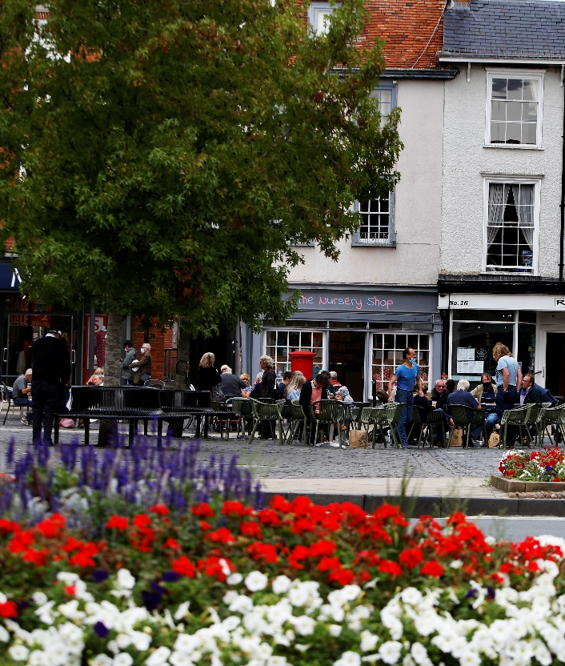
Strategic Lead – Simon Hewings – Head of Finance
We will:
- manage the council’s resources responsibly and make effective use of the council’s assets
- do our best to build financial resilience to protect the council against future uncertainties
- work across the public sector to influence and maximise funding for local government, in order to continue to invest and provide the services residents and businesses need.

We will do this by:
- exploring and actively considering all avenues to deliver financial stability, including maximising income available to the council
- making effective use of the council’s assets acting in a manner that ensures the long-term financial viability for the benefit of our residents and the environment.

Key Activities in Q1:
With the aim of managing the council’s resources responsibly and to make effective use of the council’s assets, the Vale have conducted a Strategic Property Review during Q1 2021/22. This identified several opportunities to enhance, redevelop or transfer assets to maximise income and/or benefit the district. Its findings will be presented to the Cabinet in October.

As part of the Review, a full assessment of the council’s current licences and leases was undertaken. This work has been completed and any necessary/suggested modifications are now being progressed.

Late in 2020, the council insourced the grounds maintenance and public convenience contracts with the aim of ensuring value for money. The Technical Services Manager is working with team leaders to develop policies and review budgets going forwards.

The Vale have also implemented the use of Unit4BW, a like-for-like upgrade on our previous finance IT systems. It is designed to improve both functionality and support for in-year budgeting. Phase 2 of the programme, which will include consideration of Unit4BW to build budgets for senior managers/portfolio holders, is currently being scoped.

Furthermore, a Procurement Policy that reflects the Vale’s corporate goals and aims has been developed. It will come before the Cabinet in August 2021.

In order to build financial resilience, the identification of external funding opportunities has been recognised as part of Policy & Programmes service planning. Insight & Policy are currently exploring the potential for the rollout of bid writing training – this was previously halted by the pandemic. We have also strengthened the capacity to support signposting and access to external funding opportunities by refocusing existing resources. We have also started to explore the possibility of a flexible resource to support external funding bids across the council, as more opportunities for funding continue to be brought forward from HM Government and other external agencies, we need to consider how to position the Vale to take advantage of financial opportunities as they arise.

During Q1 2021/22, the Vale also produced a fees and charges schedule setting out how much the council expects to receive for the delivery of certain services etc. A benchmarking exercise with other local authorities is currently underway.

As a result of working across the public sector to influence and maximise funding for local government, the Vale have successfully secured external funding from the Public Sector Decarbonisation Scheme for the installation of low carbon and renewable energy at Faringdon Leisure Centre. The Council has also submitted a bid to the Levelling Up Fund for cycling infrastructure on the B4044.

We also submitted a response to HM Government’s consultation on the Future of New Homes Bonus to lobby for a fairer distribution of HM Government funding.

Performance Measures
Corporate Plan ID | Stated Aim/Project description | Measure | Cabinet Lead | Officer Lead | Performance Update
PROGRAMME 1 | Explore and actively consider all avenues to deliver financial stability, including maximising income available to the council | Narrative update on initiatives to deliver financial stability and maximise income across the Council | Cllr Andrew Crawford | Simon Hewings | Progress has been in several areas in relation to the exploration and consideration of avenues to deliver financial stability. This has included the implementation of new IT systems, the development of a property investment strategy and an ongoing funds review to provide options for treasury investments.
BSF1.1 | Introduce an Investment Strategy and associated Investment Policy which gives the Council greater ability to invest in a wider range of assets to maximise its return on capital and therefore improve its income | Narrative update on the introduction of an introduction of the investment strategy and subsequent decision-making around investing | Cllr Andrew Crawford | Simon Hewings | A Property Investment Strategy has been developed and will come to Cabinet for approval in Autumn 2021. In addition, Link Asset Services are currently undertaking a funds review which will help to provide options for treasury investments.
BSF1.2 | Commit resources to identify more third-party income, including government and other grants, to help pay for our services | Narrative update as to current initiatives to increase external funding for Council activities, with details of additional resources committed to support these activities | Cllr Andrew Crawford | Harry Barrington-Mountford | The identification of external funding opportunities has been recognised as part of Policy & Programmes service planning. Insight & Policy are currently exploring the potential for the rollout of bid writing training – this was previously halted by the pandemic.  The Vale have successfully secured external funding from the Public Sector Decarbonisation Scheme for the installation of low carbon and renewable energy at Faringdon Leisure Centre. Reviews have also been undertaken to identify the availability of funding for the Gateway office project – this has so far proved unsuccessful.  The Council has also submitted a bid to the Levelling Up Fund for cycling provision on the B4044.
BSF1.3 | Identify opportunities to generate additional income from our services and assets and review these annually as part of the budget setting process | Narrative describing activity/referring to programme 1 narrative | Cllr Andrew Crawford | Simon Hewings | A fees and charges schedule has been produced. A benchmarking exercise comparing our fees with other local authorities is currently underway.
Performance Measures
Corporate Plan ID | Stated Aim/Project description | Measure | Cabinet Lead | Officer Lead | Performance Update
BSF1.4 | Review the schedule of existing contracts to identifying opportunities for rationalisation and savings | Narrative update initially detailing BAU activity to support this aim, until specific project is kicked off at which point reporting would be based on the project activity | Cllr Andrew Crawford | Simon Hewings | No progress reported Q1 2021/22
BSF1.5 | Upgrade the council’s finance IT systems to improve functionality and support in-year budget monitoring | Narrative report on the implementation of new systems, and then a yearly light-touch review | Cllr Andrew Crawford | Simon Hewings | The Vale implemented the use of Unit4BW. This is a like for like upgrade on the Council’s previous finance IT systems and is designed to improve both functionality and support for in-year budgeting. Phase 2 of the programme, which will include consideration of Unit4BW to build budgets for senior managers/portfolio holders, is currently being scoped.
BSF1.6 | Lobby for the ability to set our Council Tax at a level that can sustain council services while seeking opportunities to reduce council tax for those on the lowest incomes | Narrative report covering external influencing/lobbying work (and work with partners) and additionally, relevant information pertaining to Council Tax decisions within the Council. | Cllr Andrew Crawford | Harry Barrington-Mountford | The Vale did not submit any lobbying letters in respects to the level of Council Tax during Q1 2021/22.
BSF1.7 | Lobby for a fairer distribution of government funding and more devolution of funding to councils to sustain essential local services | Narrative report detailing lobbying activity over the period and any successes occurring as a result | Cllr Andrew Crawford | Harry Barrington-Mountford | The Vale did not submit any lobbying letters in respects of either the fairer distribution of HM Government funding or financial devolution during Q1 2021/22. A response was, however, submitted to a consultation on the future of New Homes Bonus.
PROGRAMME 2 | Make effective use of the council’s assets acting in a manner that ensures the long-term financial viability for the benefit of our residents and the environment | Narrative report on the progress of the Strategic Property review and other relevant initiatives |  | Chris Traill | The Strategic Property Review identified several measures to improve the performance of the Vale's assets. Its findings will be considered by the Cabinet in October.  The corporate landlord will help to ensure that all of the Council's assets are run as cost effectively as possible.

Performance Measures
Corporate Plan ID |  | Stated Aim/Project description |  | Measure | Cabinet Lead | Officer Lead | Performance Update
BSF2.1 |  | Develop a comprehensive and ethical Procurement Policy that reflects our corporate goals and aims |  | Narrative update reporting on completion of activity and an annual review of success | Cllr Andrew Crawford | Simon Hewings | A Procurement Policy that reflects the Vale’s corporate goals and aims has been developed. It will come before the Cabinet in August 2021.
BSF2.2 |  | Conduct a Strategic Property Review to identify opportunities to enhance, redevelop, transfer the council’s assets to maximise income and/or benefit to the district | Narrative report on the progress of the SPR |  | Cllr Andrew Crawford | Chris Traill | The Strategic Property Review (SPR) identified several opportunities to enhance, redevelop or transfer assets to maximise income and/or benefit the district. If the outcomes of the SPR are approved by the Vale Cabinet in October, they can then proceed to be actioned.
BSF2.3 | Complete an asset management plan to provide a comprehensive policy to inform how assets may be most efficiently maintained |  | Narrative report on progress of this within the SPR |  | Cllr Andrew Crawford | Chris Traill | The completion of an assets management plan for the Vale is ongoing. CIPFA is to be instructed s as part of the corporate landlord implementation process.
BSF2.4 | Undertake a full review of all leases and licences to ensure council income is collected when due and maximised |  | Narrative report on progress of this within the SPR |  | Cllr Andrew Crawford | Chris Traill | A full review of all leases and licences was undertaken as part of the Strategic Property Review. This work has now been completed.

Performance Measures
Corporate Plan ID | Stated Aim/Project description |  | Measure | Cabinet Lead | Officer Lead | Performance Update
BSF2.5 | Undertake a detailed review of the financial position of the Beacon in Wantage and determine what changes to its operations can be made to improve its viability |  | Narrative update on the review of financial position of the Beacon | Cllr Andrew Crawford | James Carpenter | Initial discussions have been held with the Cabinet Member to understand the information that is being sought as a baseline. Due to the pandemic, there was no trading data for the last financial year.  During Q1 2021/22, the Beacon has remained closed – it has been serving as a Covid-19 testing site. It is scheduled to reopen in September.
BSF2.6 |  | Insource our grounds maintenance and public conveniences contracts to save funds and increase flexibility over how our public spaces are used and managed | Narrative update on the activities of the new insourced team and the initiatives being undertaken | Cllr Andrew Crawford | Liz Hayden | The grounds maintenance and public conveniences contracts were insourced during 2020/21. The Technical Services Manager is currently working with team leaders to develop policies and review budgets. Due to the need to invest in equipment and machinery it is unlikely that savings will be realised in the short-term.

Theme 5: Working in partnership

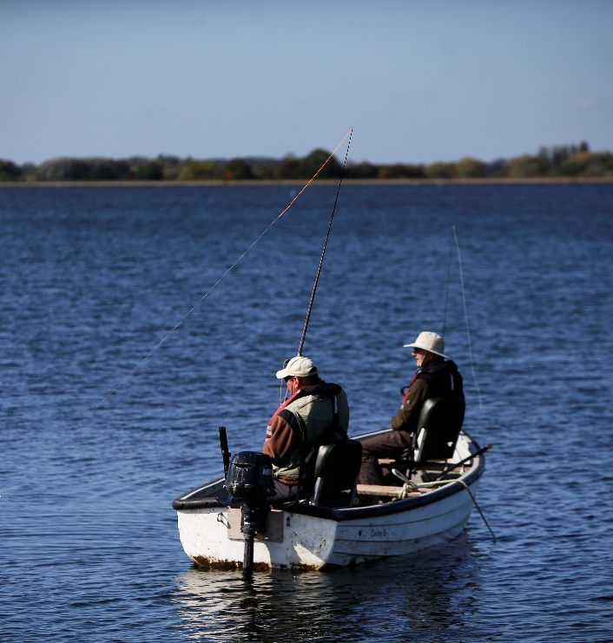
Strategic Lead – Adrianna Partridge and Suzanne Malcolm – Deputy Chief Executives

We will:
- work in partnership with other councils, authorities and businesses, non-profit organisations, community and residents’ groups, to achieve our aims and objectives effectively, efficiently and fairly
- provide support to residents and organisations to effect and drive change in the community
- provide all the support we can to businesses in the Vale to help them succeed.

We will do this by:
- working in partnership to influence and shape regional and national agendas to maximise opportunities for our communities and businesses
- working with and supporting our residents, businesses and communities to effect and enable change.

Key Activities in Q1:

In order to help deliver on our commitment to work in partnership with other councils, authorities and businesses, non-profit organisations, community and residents’ groups, the Vale is actively engaged in both county and Arc-wide proposals and policies. These include economic recovery plans which aim to understand the impact of the pandemic on the local economy, shape the support available to businesses and residents and build back better.

The council, in agreement with the other local authorities in Oxfordshire, has also agreed a joint strategic vision for long-term sustainable development across the county. This sets out what growth should look like based on the principles of improving social, environmental and economic wellbeing for all.
7

RESPONSES TO EXTERNAL CONSULTATIONS SUBMITTED

In partnership with Oxfordshire County Council, we have also received sign-off from the Department for Transport on the introduction of civil parking enforcement in the Vale of White Horse. Officers are currently drafting a cabinet report to confirm the changes required in the council’s off-street car park orders, with a planned soft launch/transition for the new regime scheduled to begin in November 2021 and be completed by January 2022.

To assist in furthering our partnership work with community and residents’ groups, officers are in the process of developing a programme of town and parish council engagement events. This work will build upon the on the lessons learned from two recent events (the Assets of Community Value webinar and the Climate Change forum).
3

NEIGHBOURHOOD PLANS ADOPTED

Over the last quarter, the Vale has also made progress in improving the efficiency and effectiveness of our partnership working. We have introduced a corporate recording process for consultation responses which is designed to not only provide oversight and co-ordination, but also measure impact. Further work is also planned to assess and measure the impact of the Vale’s submissions. This will include identifying opportunities to strengthen the council’s voice via national representative and lobbying organisations. We are also looking to promote and publish the consultations we are responding to on our website.

In addition, the council has been developing this quarter a draft Partnership Protocol to assist in the both the creation and management of our relations with external organisations. There is the potential for it to piloted when the Vale explores the possibility of entering into any future strategic partnerships.

With the aim of providing support to residents and organisations to effect and drive change in their communities, the Vale has made further progress on the development of a community lottery during Q1 2021/22. The necessary licences have been applied for and a virtual launch event was hosted to raise awareness/encourage sign-up from community groups. The first draw is expected to take place later in the year.
£1.8 m

IN ADDITIONAL RESTRICTIONS GRANTS (ROUND 2)

The council has also assisted communities in having a greater say in the future of the places where they live and work through its continued support for Neighbourhood Plans. During Q1 2021/22, three such plans (North Hinksey, Cumnor and Shrivenham) were adopted – bringing the total number of made Neighbourhood Plans in the district to 12.

Further, an updated CIL Spending Strategy came into force in the Vale on 1 April 2021. This will help to allocate funding for the delivery of infrastructure to support development and will, thereby, be used to ensure that communities have the requisite amenities and services for the future.

As a means to providing all the support we can to businesses in the Vale to help them succeed, the council has focused during Q1 2021/22 on the delivery of Covid-19 discretionary business grants. During the Additional Restrictions Grant Round 2, we paid out £1,805,000 to 601 businesses. In addition, £1,753,419 was given to 588 businesses through the Additional Restrictions Remobilisation Grant.
£1.75 m

IN REMOBILISATION GRANTS TO 588 BUSINESSES

The Vale also provides weekly business intelligence reports to OxLEP. This information feeds into both the Oxfordshire and the Department for Business, Energy & Industrial Strategy economic recovery plans. Officers also attend meetings of the Oxfordshire Economic Recovery Task Group and Oxfordshire Business Support.

In addition, the Vale signed the Reopening High Streets Safely Fund grant funding agreement on 26 June 2021.

Concurrently to the work directly related to the economic recovery from the pandemic, the council’s Economic Development team, in partnership with Start Your Own Business, has created a free, local guide for businesses based in South and Vale. This has so far been distributed to 34 companies.

The Vale has also agreed two Community Employment Plans. These aim to ensure that local people can better access job opportunities.

Performance Measures
Corporate Plan ID | Stated Aim/Project description | Measure | Cabinet Lead | Officer Lead | Performance Update
PROGRAMME 1 | Work in partnership to influence and shape regional and national agendas to maximise opportunities for our communities and businesses | Narrative report on work with partners across the organisation which will maximise opportunities for communities and businesses |  | Harry Barrington-Mountford | The Vale is actively engaged in both county and Arc-wide proposals and policies. These include economic recovery plans which aim to understand the impact of the pandemic on the local economy, shape the support available to businesses and residents and build back better.  The Council has also agreed a joint strategic vision for long-term sustainable development across Oxfordshire. This sets out what growth should look like based on the principles of improving social, environmental and economic wellbeing for all.  The Vale is also exploring the possibility of a strategic partnership to further the corporate priority to tackle the Climate Emergency
WIP1.1 | Create a partnerships protocol. Map our current partnerships and assess the effectiveness of each. clarify which local, regional, and national partnerships Vale needs to have an active presence in and focus resource accordingly. | Narrative update on the position of this work and an annual review after its completion | Cllr Bethia Thomas | Harry Barrington-Mountford | A draft Partnerships Protocol is being developed and mapping work has commenced this quarter. There is the potential for its use to be piloted and launched when exploring future strategic partnerships.
WIP1.2 | Develop an enhanced consultations strategy and process to ensure we respond to consultations and proactively lobby national government and other bodies on matters that impact our corporate priorities | Narrative update on proactive work to lobby govt and key organisations, update on key consultations responded to within the period.  Quantitative -- Number of consultations replied to. | Cllr Neil Fawcett | Harry Barrington-Mountford | A corporate recording process for consultation responses has been developed and implemented. This is designed to not only provide oversight and co-ordination, but also measure impact. Consultations are ranked according to type (Strategic/General/Technical).  As of Q1 2021/22, seven consultations have been processed to (3 strategic and 4 general). To date, the issuing agencies have yet to publish their responses.  Further work is planned to assess and measure the impact of the Vale’s submissions. This will include identifying opportunities to strengthen the council’s voice via national representative and lobbying organisations.

Performance Measures
Corporate Plan ID | Stated Aim/Project Description | Measure | Cabinet Lead | Officer Lead | Performance Update
WIP1.3 | Create a framework that sets out how we will engage with developers, other councils, and members to maximise opportunities for our priorities to shape development | Narrative update on the work of planning and engagement activity | Cllr Judy Roberts | Eliot Ward | Following the completion of the Strategic Property Review, officers will begin investigating opportunities on identified sites. They will consider whether these require a company or can be delivered by the council (either individually or in partnership with others).
WIP1.4 | Work with businesses to undertake economic development review to ensure that council is providing support to SMEs, homebased businesses, supporting skills development, and ensuring that businesses are playing a role in place making | A narrative report of activity to undertake an economic development review and details of how the Council is supporting SME's at this time.  Quantitative information from CRM detailing number of businesses engaged with | Cllr Bethia Thomas | Chris Traill | The focus in Q1 2021/22 was on the delivery of Covid-19 discretionary business grants. During the Additional Restrictions Grant Round 2, we paid out £1,805,000 to 601 businesses. In addition, £1,753,419 was given to 588 businesses through the Additional Restrictions Remobilisation Grant.  In terms of skills, two Community Employment Plans have been agreed. These aim to ensure that local people can better access job opportunities. In addition, 839 users have accessed the iDEA Programme.  The Vale also received 45 expressions of interest from occupiers in relation to our space project. There are only, however, 10 potential units available.
WIP1.5 | Strengthen any existing network of local business groups to increase awareness of the council’s ED programmes and communication throughout the district | Detail engagement with small business newsletter, number of recipients, clickthrough | Cllr Bethia Thomas | Chris Traill | The Council received 800 e-mail enquiries seeking support.  There are 2,456 subscribers to our newsletter and the South and Vale Business Support website is visited more than 1,400 times each month.
WIP1.6 | Input into countywide and Arc-wide economic recovery plans to maximise understanding of the local impact of Covid-19 and to help shape the support available to our local economy | Narrative update on activity supporting WIP 1.5 | Cllr Neil Fawcett | Chris Traill | The Council provides weekly business intelligence reports to OxLEP. This information feeds into both the Oxfordshire and the Department for Business, Energy & Industrial Strategy economic recovery plans. In addition, officers attend meetings of the Oxfordshire Economic Recovery Task Group and Oxfordshire Business Support.  The Vale has also submitted an application for Levelling Up funding to HM Government.
Performance Measures
Corporate Plan ID | Stated Aim/Project Description | Measure | Cabinet Lead | Officer Lead | Performance Update
WIP1.7 | Work with Oxfordshire County Council to introduce civil parking enforcement for the Vale | Narrative update on progress in this area, if impacts are seen in other areas as a result of this activity, those impacts should be included (PnD parking income for example) | Cllr Neil Fawcett | Liz Hayden | The Department for Transport have signed off on the application to introduce civil parking enforcement within the Vale. A joint press release has been issued to this effect.  Officers are currently drafting a cabinet report to confirm the changes required in the Council’s off-street car park orders, while Oxfordshire County Council are identifying locations for on-street parking bays to charge.  We are planning for a soft launch of civil parking enforcement, so that people can learn about the changes and be encouraged to park responsibly. It is proposed that the transition will start in November 2021 with the move to the new system scheduled for January 2022.
PROGRAMME 2 | Work with and support our residents, businesses and communities to effect and enable change | Narrative update on work with Parish Councils, particularly relating to the transfer of management of assets. Update on other activity that directly supports residents and business effecting change.  Quantitative elements - number of neighbourhood plans adopted, number of community initiatives undertaken, breakdown of assets where management has been transferred |  | Harry Barrington-Mountford | Officers are in the process of developing a programme of town and parish council engagement events. This work will reflect on the lessons learned from our first two events (the Assets of Community Value webinar and the Climate Change forum).  Council staff are also in the process of producing communications plans for each of the Vale’s corporate plan themes.  Three neighbourhood plans were adopted during Q1 2021/22 (North Hinksey, Cumnor and Shrivenham).
WIP2.1 | Support new business start-ups and support schemes for businesses and residents through post Covid-19 economic recovery initiatives, by implementing the “Opening Up High Streets Safely Fund” and associated schemes | Narrative update on support schemes for businesses and residents. Updates on any relevant schemes should be included | Cllr Bethia Thomas | Chris Traill | The Economic Development team, in partnership with Start Your Own Business, created a free, local guide for businesses based in South and Vale. This has so far been distributed to 34 companies.  The Vale signed the Reopening High Streets Safely Fund grant funding agreement on 26 June 2021.
Performance Measures
Corporate Plan ID | Stated Aim/Project Description | Measure | Cabinet Lead | Officer Lead | Performance Update
WIP2.2 | Find ways to elevate the understanding of and promote Neighbourhood Plans in planning decisions with a review of development appraisal and communications with all parties prior to an application coming to committee | Narrative update on activity to support and promote Neighbourhood plan adoption.  Quantitative measure - number of Neighbourhood plans adopted | Cllr Bethia Thomas | Adrian Duffield | Internal planning communications confirm new neighbourhood plans and the significant weight they carry when determining planning applications. All relevant parish councils are informed of the Council’s decision to make Neighbourhood Plans and webpages are updated accordingly.  The Vale currently has 12 made Neighbourhood Plans, three of which were adopted during Q1 2021/22. Once a Neighbourhood Plan has been made, the Neighbourhood Planning Group will be invited to attend a workshop with planning officers.
WIP2.3 | Review the planning committee process to identify ways to maximise public understanding, engagement and participation as well as supporting member input into the committee meetings with opportunities for training and development | Narrative update on activities to review and promote the activities and understanding of the planning committee.  Quantitative elements - Online engagement figures relating to the planning portal/planning sections of the website. | Cllr Bethia Thomas | Adrian Duffield | Vale has provided feedback to MCHLG on the use of virtual planning committees as part of their review of the Local Government Act 1972.  Three meetings of the committee were held during Q1 2021/22. They received 114 (21/04), 90 (02/06) and 52 (23/06) views respectively.  The Chair of the Planning Committee and the relevant Cabinet Member receive monthly monitoring of planning committee decisions.  In June, training on planning conditions was provided to members of the Committee.
WIP2.4 | Review developer contribution collection and spend policy and improve ward member and parish council involvement with a clear timetable that is triggered by officers, with improved communication from the council | A narrative update on activities relating to the spend of CIL  Quantitative element - Breakdown of CIL spend by type/amount/area | Cllr Judy Roberts | Chris Traill | The CIL spending strategy was updated in December 2020. It came into force on 1 April 2021.  Quarterly CIL and S106 spend/income reports are provided to Cabinet Members.  The CIL charging schedule is currently being reviewed by the Planning team.
Performance Measures
Corporate Plan ID | Stated Aim/Project Description | Measure | Cabinet Lead | Officer Lead | Performance Update
WIP2.5 | Refresh our community grants scheme and introduce a Community Lottery to raise funds for groups to develop in line with our corporate objectives | Narrative report on activity relating to new community grants, information relating to the implementation of the Community Lottery, and once implemented performance metrics | Cllr Bethia Thomas | James Carpenter | Progress has continued to be made on the development of a community lottery. The necessary licences have been applied for and a virtual launch event was hosted to raise awareness/encourage sign-up from community groups. The first draw is expected to take place later in 2021.  The Vale does not currently offer a community grants scheme.

Theme 6: Working in an open and inclusive way

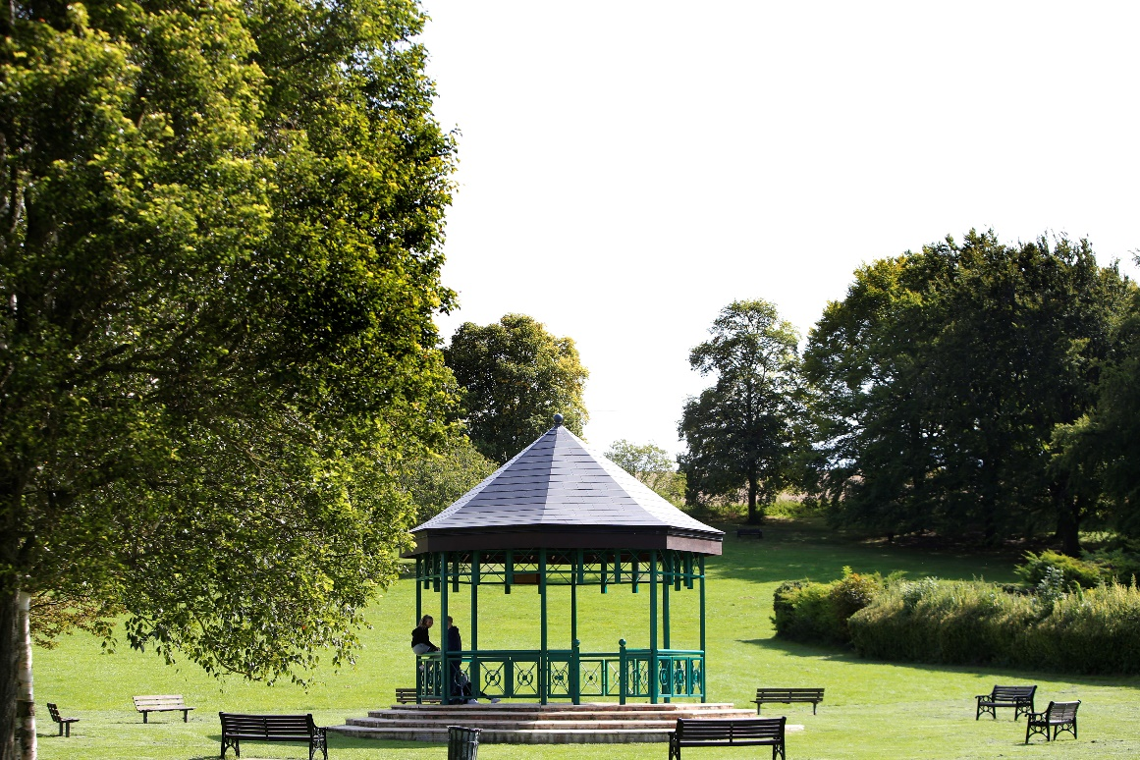
Strategic Lead – Adrianna Partridge- Deputy Chief Executive – Transformation and Operations
We will:
- work openly and transparently, promoting a world in which all can participate equally
- listen to feedback from local residents, communities, businesses, partners and our own officers
- ensure our work particularly aims to include those groups that have historically been marginalised or those that have been hard to reach
- ensure we are accountable and that our decisions are open to appropriate scrutiny, and we will admit when we get things wrong.

We will do this by:
- improving our use of technology to increase understanding and access to what we do, how we work and the decisions we make
- increasing meaningful engagement and communication with everyone
- strengthening our governance framework and address our policy gaps, improving transparency.

Key Activities in Q1:
Seeking to strengthen our governance framework and address policy gaps, Policy and Programmes have identified those policies and strategies which will need to be developed to deliver on our commitments in the corporate plan and have been reviewing their service plan in order to work with teams across the council in the development of these policies and strategies. Linked to this work, an optimisation review of the Corporate Delivery Framework is also currently underway, to ensure the right tools are available to officers.

Improving our use of technology to increase understanding and access to what we do has been highlighted as a key aim. A Digital Officer has been appointed and will lead on this area of work.
163

FOI/EIR
RECEIVED

Central to fulfilling our commitment on the use of technology is the delivery of the new Vale website. The new site provides an online portal for both residents and businesses. An accessibility audit has been undertaken to make certain that the website is accessible to all and work is ongoing to ensure that the site functions well across multiple devices and platforms.

In addition, the Information Governance team are reviewing what information could usefully be published on the council’s website so that information requested is more easily and immediately accessible to the public, avoiding the need for Freedom of Information (FOI) or Environmental Information Regulations (EIR) requests.
27

STAGE 1 COMPLAINTS RECEIVED

The live streaming and recording of meetings was highlighted as a key part of enhancing our accountability and transparency and increasing the scope for communication and engagement with residents across the district. As such, in Quarter 1 of 2021/22, all public Council meetings were livestreamed and then put up on the Councils’ joint ‘committee meetings’ YouTube Channel, where they remain available for the public to view: South and Vale Committee Meetings - YouTube

Changes to the legal provisions for holding remote meetings and the return to face-to-face meetings presents the Council with various challenges that will have to be met if we are to continue to make meetings accessible online, live or recorded. We have now returned to in-person meetings where this is required of us but continue to allow remote public and officer participation. In this mixed approach we are seeking to maintain our high standards for transparency and engagement.
5

STAGE 2 COMPLAINTS RECEIVED

To improve the public understanding of what we do the communications team held regular strategic communications meetings with the Cabinet Member and the Leader of the Council to ensure the active communication of decision making and outcomes.

Work is underway on the production of communication plans for each of the Vale’s corporate priorities as well as on an overarching Digital Strategy.

Throughout Quarter 1, the communications team have continued to seek to engage residents across various media platforms and outlets. A review of our current engagement channels and data sets is underway, to determine their effectiveness and what further actions can be taken to engage with under-represented groups.

In line with our commitment to increase meaningful engagement with everyone, the Council has run Town and Parish Forum events on Assets of Community Value and Climate Change. A programme of further engagement events is currently being developed. To meet our commitment to refresh Town and Parish Forums so that they are more interactive and useful for communities, a review of previous Forums has been started; the findings of which will feed into a learning document.

Work is now underway to lay the groundwork for a refreshed residents’ survey. This workstream will be instrumental in meeting our commitment to listen to feedback from local residents, communities and businesses, and to include those groups that have historically been marginalised or those that have in the past, been hard to reach.

Monitoring and addressing complaints is also an important element in listening to residents, businesses and communities and holding the Vale to account. During Quarter 1, the council received 32 complaints. 27 are stage one and five are at stage 2.

The Census 2021 was completed this quarter. The Council worked collaboratively with the Office for National Statistics on ensuring strong engagement and uptake amongst our communities. The household response rate within the vale exceeded 90%. Quality assurance and review of the data is expected to take place in the next quarter.

The Vale’s templates and report writing guidance have been updated to reflect the central importance of the climate emergency and to ensure that a recognition of this is part of the decision-making process across our operations.

Over the course of Quarter 1, important steps have been taken in Council policy, governance and operations in support of our commitment to tackle the climate emergency. The Cabinet have supported both the establishment of a Growth Board Environment Advisory Group and the development of an Arc Environment Strategy. They have also adopted policies and key actions related to the Oxfordshire Electric Vehicle Infrastructure strategy and endorsed measures that would reduce the negative impacts of EV battery production. In addition, the General Licensing Committee have adopted a revised taxi licensing policy which includes provisions on vehicle emissions.
Performance Measures
Corporate Plan ID | Stated Aim/Project description | Measure | Cabinet Lead | Officer Lead | Performance Update
PROGRAMME 1 | Improve our use of technology to increase understanding and access to what we do, how we work and the decisions we make. | Narrative update on any work relating to technological implementation/adaptation and processes making greater use of existing technology to bring about efficiency or increase accessibility. | Cllr Bethia Thomas | James Carpenter | A Digital Officer has been appointed to lead this workstream from a comms and marketing point of view. Work has also been progressing on finalising the draft Digital Strategy. This is due for discussion by Vale Cabinet later in the year.
WIOI1.1 | Provide and maintain a new Vale website with increased accessibility to services and information, on multiple devices | Quantitative report on website usage | Cllr Bethia Thomas | James Carpenter | The Vale has delivered a new website which provides an online portal for both residents and businesses. This has already undergone an accessibility audit to confirm that it is fit for purpose and further work is currently being undertaken to ensure that we continue to meet all of the necessary requirements.
WIOI1.2 | Develop our use of social media platforms to reach and engage with more residents and local businesses | Narrative report on new social media initiatives  Quantitative report on social media engagement | Cllr Bethia Thomas | James Carpenter | No progress reported Q1 2021/22
WIOI1.3 | Introduce live streaming and recordings of public meetings to increase accessibility and understanding of the democratic process | Number/Percentage of public meetings streamed live  Number/percentage of public meetings available to watch online | Cllr Emily Smith | James Carpenter | During Q1 2021/22, all Council meetings were livestreamed before being uploaded to YouTube. As the legal provisions for holding remote meetings have altered, maintaining this 100% performance will be challenging.  Regular strategic communications meetings are held with the Cabinet Member and the Leader of the Council to ensure the active communication of decision making and outcomes.
WIOI1.4 | Review the current use of online surveys assessing their take up over time, and by subject, as well as reviewing survey design | Narrative update on survey utilisation/progress towards this review/details of any particularly successful surveys | Cllr Bethia Thomas | James Carpenter | The platform for online surveys will be determined once a decision on the type of engagement required has been made. The best methodology will be dependent on the audience.
Performance Measures
Corporate Plan ID | Stated Aim/Project description | Measure | Cabinet Lead | Officer Lead | Performance Update
PROGRAMME 2 | Increase meaningful engagement and communication with everyone | Narrative update on successful communication initiatives |  | James Carpenter | As part of their business-as-usual activities, the Communications team continue to seek to engage across various media platforms and outlets. In recent months, the Council has run Town and Parish Forum events on Assets of Community Value and Climate Change. A programme of further engagement events is currently being developed.  Work is also under way on the production of communications plans for each of the Vale’s corporate priorities.  The upcoming publication of Census data will help to inform our equalities and diversity approach. It will also help us to better understand the needs of harder to reach groups and allow us to improve our engagement approach accordingly.
WIOI2.1 | Ensure the creation of community liaison groups form part of all early stages of development planning, to understand local infrastructure needs and support community cohesion | Narrative update on the creation and utilisation of community liaison groups and the development of the policy  Quantitative measure - number of community liaison groups | Cllr Bethia Thomas | James Carpenter | No progress reported Q1 2021/22
WIOI2.2 | Refresh Town and Parish Forums so they are more interactive and useful for communities and develop the Connecting Communities Policy | Narrative update on Town and Parish Forums and the development of the connected communities policy | Cllr Bethia Thomas | James Carpenter | While no progress has been made on the development of a Connecting Communities Policy, a review of previous Town and Parish Forums has been started. The findings of this work will feed into a learning document.
WIOI2.3 | Work with communities, schools and other local organisations on shared campaigns and initiatives that help further our corporate objectives | Narrative update on comms and engagement activities which interface with communities, schools and other local organisations | Cllr Bethia Thomas | James Carpenter | No progress reported Q1 2021/22
Performance Measures
Corporate Plan ID | Stated Aim/Project description | Measure | Cabinet Lead | Officer Lead | Performance Update
WIOI2.4 | Reinstating residents’ surveys in a refreshed form - deliver effective ways for the public to have their say, to reach more people, mechanisms for feedback, more timely dialogue, educate and provide subject matter information to facilitate opinions being more informed | Narrative update to be provided on the progress of this work | Cllr Bethia Thomas | James Carpenter | The previous residents’ survey and results has been reviewed. The data contained within it has reached the end of its currency.  Work is now underway to lay the groundwork for a refreshed residents’ survey. This will consider the right format for the collection of data; what data can be used to inform an appropriate baseline; and what the overall objectives of the survey will be. The preliminary findings of this exercise will be used to inform an initial discussion with the Cabinet Member.
WIOI2.5 | Explore initiatives to increase voter registration and turnout levels at elections, especially amongst young people | Narrative update on individual initiatives and opportunities to encourage voter registration | Cllr Emily Smith | James Carpenter | The Communications team provided support to Democratic Services in promoting May’s elections. This assistance was general in nature and did not specifically target certain groups e.g. young voters.  The Vale’s future comms approach to encouraging voter registration and turnout will be mapped out as part of our wider communications plans.
WIOI2.6 | Ensure council’s consultations engage specifically with young people and other under-represented groups | A narrative report with input from the engagement/comms teams and the equalities officer on activity to encourage these groups | Cllr Bethia Thomas | James Carpenter | The Council has started a review of our current engagement channels and data sets in order to determine their effectiveness and what further actions can be taken to engage with under-represented groups. This work will need to be baselined against the findings emerging from Census 2021.

Performance Measures
Corporate Plan ID | Stated Aim/Project description | Measure | Cabinet Lead | Officer Lead | Performance Update
PROGRAMME 3 | Strengthen our governance framework and address our policy gaps, improving transparency | Narrative update on policies/strategies currently in development/awaiting approval/recently approved. |  | Harry Barrington-Mountford | Policy and Programmes have identified 56 policies and strategies contained within the Annual Delivery Plan. The Insight & Policy team can be used to support their further development. Arrangements are currently being made to implement bespoke assistance – this will include training for relevant service staff.  An optimisation review of the Corporate Delivery Framework is also currently underway.
WIOI3.1 | Work to adopt new CIPFA financial management code to enhance our financial governance | Narrative update detailing the elements of the code which have been implemented, which are underway, and which are yet to be started | Cllr Andrew Crawford | Simon Hewings | No progress reported Q1 2021/22
WIOI3.2 | Council reporting and decision-making templates to include impact on the climate emergency | Narrative update on significant decisions which have key environmental considerations, additionally any updates to key policies which have a focus on the climate emergency | Cllr Debby Hallett | Margaret Reed | The Vale’s templates and report writing guidance have been updated to reflect the climate emergency.  As of Q1 2021/22, the Cabinet have supported both the establishment of a Growth Board Environment Advisory Group and the development of an Arc Environment Strategy. They have also adopted policies and key actions related to the Oxfordshire Electric Vehicle Infrastructure strategy and endorsed measures that would reduce the negative impacts of EV battery production.  In addition, the General Licensing Committee have adopted a revised taxi licensing policy which includes provisions on vehicle emissions.
Performance Measures
Corporate Plan ID | Stated Aim/Project description | Measure | Cabinet Lead | Officer Lead | Performance Update
WIOI3.3 | Review the councils constitution and scheme of delegation annually | Narrative update with the outcome of the review | Cllr Debby Hallett | Margaret Reed | During Q1 2021/22, the Vale returned to in-person meetings where required. We are, nevertheless, continuing to allow remote public and officer participation. In addition, informal virtual meetings are continuing where they are best suited to the purpose of the items/topics being discussed.  Ongoing constitution updates are scheduled to be agreed by the Council in July and October 2021. The annual constitution review is planned for Q3 2021/22.
WIOI3.4 | Increase and improve publicly available information – e.g.- code of conduct complaints (decision noted) FOIs (responses), corporate complaints (data)Improve accessibility of corporate information through publishing on our website | Narrative update on relevant reviews/newly available information/website improvements and metrics  Quantitative - FOI/Complaints data | Cllr Debby Hallett | James Carpenter | Freedom of Information (FOI) and Environmental Information Regulations (EIR) contact with the Council remains high. In Q1 2021/22, the Vale received 163 FOI/EIRs.  The Information Governance team are currently reviewing what information could usefully be published on the council’s website to reduce the numbers of repeat FOIs. Longer-term, work is planned in relation to both the Transparency Code and the FOI publication scheme.  There were 27 stage one complaints between April-June and 5 stage two.

Covid-19 Response and recovery

Covid-19 has been an unprecedented challenge which required the Council to react quickly to changing circumstances, in order to support local businesses, the economy, the voluntary and community sector and local residents. We have worked hard to maintain essential services whilst redeploying staff to new areas of work to help deal with the crisis. The Council developed a Community Hub team during the pandemic to work effectively with voluntary sector partners and volunteers.

This team continue to collaborate with our partners at a County-wide level, including close coordination and good communication between the County, City and District Councils, with the NHS and OxLEP, to support vulnerable people and encourage vaccination uptake in the district.

COVID-19 Community Hub Support distributed between 1 April and 30 June

13
FOOD PARCELS

34
TEST & TRACE PAYMENTS REFERRALS

£3.4m
TO LOCAL BUSINESSES

14
VOUCHER REFERRALS

£106,231
TO VOLUNTARY SECTOR AND HOUSEHOLDS

