Communications and engagement strategy

**Our vision**

**To create districts where our diverse audiences have a voice, are aware of the services and support the councils provide, and what they are doing to make South and Vale thriving places.**

By building a better understanding and acceptance of what we do and why and through listening to our communities, we can manage and improve the impression our audiences have of us and encourage and motivate more of them to voice their views on our work and services.

The strategy will:

* set out the councils’ approach for communicating and engaging with their audiences
* describe how we will improve our communications with all sectors and groups in our communities using appropriate channels and methods
* help deliver the priorities in the councils’ corporate plans
* establish that good communication is everyone’s responsibility
* raise awareness of each council’s leadership roles in addressing district wide issues and delivering better outcomes for their communities
* demonstrate the councils’ commitments to fully inform and listen to their audiences
* set the standards for good communications and engagement.

This strategy has been produced to align with the councils’ Corporate Plans and underpins all their corporate priorities but particularly *Working in an open and inclusive way (Vale)* *and Openness and accountability (South)*.

There are also several supporting/cross cutting strategies already in place or in development that contribute to these objectives– see Appendix 2.

This strategy is primarily for internal use but in the interests of transparency it will be available on our websites.

**Our aims?**

1. To ensure all our varied audiences have a clear and positive understanding of:

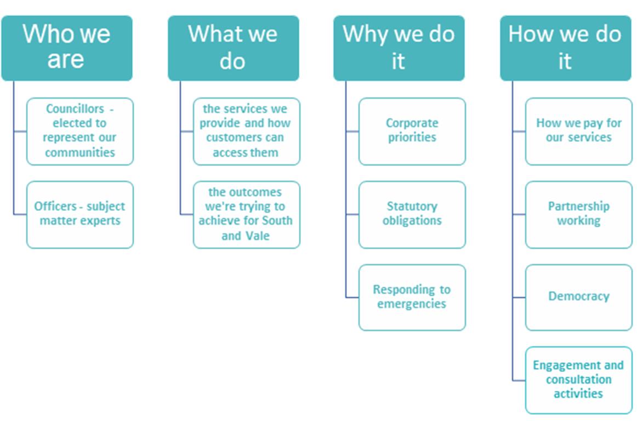

1. To ensure all our diverse audiences can tell us what they think of us and the work we’re doing and can give us their views on service and policy proposals when there are meaningful opportunities to influence these.

**Our approach**

We will achieve our aims through:

* Ensuring the right structure is in place to provide a modern and strategic communications and engagement service
* Putting in place fresh communications and engagement policies and procedures
* Delivering well planned and expertly executed communications that reach all our audiences
* Ensuring timely and proportionate engagement activities
* Proactively promoting and publicising our services and activities, how they relate to our corporate priorities and our progress
* Being on the front foot with potential issues that could affect the councils’ reputations
* Promoting existing and new digital technologies that allow our customers to contact us and provide feedback quickly and easily
* Strengthening the use of our brand to raise awareness of our services and work
* Developing our social media platforms both to keep audiences informed of our news and events and to encourage interaction.

**Our standards**

Through all our communications and engagement activities we will speak positively and proactively about the work the councils are doing to identify and achieve the best possible outcomes for their communities.  We will also explain our decisions and the thinking behind them, especially when facing criticism, so our audiences understand why we’ve approached things in a certain way.

Our communications and engagement will:

* Have a **CLEAR** and defined purpose and audience.
* Be **ACCESSIBLE** and **INCLUSIVE**. We’ll use conversational tone, plain English and imagery to ensure our communications and engagement are as inclusive as possible.
* Be **TIMELY.** We’ll tell our audiences about matters that could affect them and opportunities to provide feedback in plenty of time and in the most appropriate way – our communications will be regular, consistent and appropriate for the audience.
* Be **CONCISE** We will get to the point.
* Be **HONEST** We will be open and truthful speaking in facts, not speculation and spin. We will be realistic and set our audiences’ expectations appropriately and not over-promise.

**Our key messages**

Many of our key messages over the life of this strategy will be informed by our:

**Priorities**

Most of the councils’ work is driven by the priorities in their Corporate Plans, therefore these will feature heavily in all our public messaging.  When we’re responding to emergencies and additional demands placed on us by government, we’ll focus on our role, the support we can offer and the benefits to the target audience.

**Financial standing**

The councils’ financial forecasts remain uncertain, and they may in the future have to take unpopular decisions to deliver on their priorities *to build stable finances (Vale)* *and rebuild financial viability (South)* while protecting vital services. Our communications will therefore need to manage future expectations.

**Future service delivery models**

The Covid-19 pandemic has forced many organisations like ours to provide more digital services and self-service options. This trend is likely to continue as more audiences embrace the convenience they offer, and if further efficiency savings are required.  Effective communications will be crucial for ensuring this approach lands positively with all audiences, particularly those that may struggle with digital services or have difficulties accessing them.

**Our areas for development**

We have identified several areas we need to strengthen over the life of this strategy, based on feedback received, learning from best practice and spotting opportunities for continuous improvement. We will produce annual action plans to achieve this. The key areas for developing are:

**Campaigns**

Over the years, our campaign work has tended to focus on recycling and waste collection matters, as it’s one of the few services that easily lend themselves to this activity.  However, there is much more we can do.  People often associate campaigns with promoting services and new activities, but they are a successful and effective way of addressing council issues, influencing behaviours and contributing to the delivery of corporate priorities.  Therefore, delivering well planned and executed campaigns will be a focus of this strategy as well as measuring their impact using a range of metrics.

**Social and digital media channels/platforms**

Since our social media policies and processes were first introduced these platforms have become established as significant communications and customer engagement tools.  We therefore need to review our overarching approach and framework to ensure they both embrace the opportunities these channels bring but also to manage the downsides positively and proactively. Given the pace of developments in this area it’s important that we review our approaches on a regular basis to stay ahead of the curve.

With devolved responsibility for maintaining web content to service representatives the website can very soon become unwieldy without strategic and central oversight.  We will therefore need to ensure the team is properly resourced to do this, along with driving forward new digital platforms and tools to meet the changing needs of our audiences.

**Reaching more people and communities**

It’s been a while since we have reviewed the way we communicate and engage with key stakeholders –groups we’ve historically failed to reach, our business communities, towns and parishes and voluntary and community organisations. This is an important exercise to ensure we’re meeting their needs.

In the meantime, we will continue to make all reasonable efforts to ensure our information is available to all audiences, including those with disabilities, who struggle with reading or don’t have English as their first language. We will also continue to do everything we reasonably can to make sure we’re reaching residents who don’t have access to the internet or aren’t comfortable using it regularly.

**Media relations**

We need to build closer working relations with our press and broadcast media as, particularly since the start of the covid pandemic, media relations activity has become a little more reactive and remote.

**Creative communications – graphics, video**

Effective digital and social media communications often requires high-quality visual materials, including photographs, video, graphics and infographics. We need to ensure the communications and engagement team has the skills to create these through training and when recruiting and has the budget to commission external expertise when needed.

**Consultation and engagement**

A national trend since the start of the pandemic is that more people than ever are taking part in consultation and engagement activities.  Whilst this is also true for the councils, our systems and approaches have been in place for some time and would benefit from a review.

The review will explore quicker and more flexible models for capturing views but also how we can engage with our audiences more informally, particularly as part of our day-to-day communications activities.

**Our audiences**

Accurately identifying our audiences is essential for effective communications and engagement activities.  Our audiences are many and varied and each will have different levels of awareness and understanding of our work and services so our key messages will need to be tailored accordingly.

Likewise, when planning campaigns and engagement activities, we will need to consider the preferences and needs of our target audience. For example, some audiences may be more familiar and comfortable with traditional media than online/ social media platforms.

* Employees and potential employees
* Council members and potential councillors
* The public – residents, customers, and groups we normally fail to reach
* Community groups and organisations
* The wider public in Oxfordshire and beyond – potential visitors
* Partners and stakeholders including other local authorities
* The media – local and national see Appendix 1
* Local MPs
* Government
* Business community
* The councils’ recognised union

**Our responsibilities**

Every decision the councils take will have an impact of at least one of their audiences – this could be one or two members of staff, a contractor or every resident. It’s therefore important to identify the communications implications of proposals before decisions are taken and made public, to be on the front foot with messaging.

As the councils’ strategic lead for communications our Communications and Engagement team are best placed to do this but must be engaged early in the process, particularly to manage any messages that might be perceived negatively with large or several audiences. However, all staff and members have a role to play in being ambassadors for getting key messages across to our audiences.

Every interaction our audiences have with staff and members has an impact on our reputation, negatively or positively. Therefore, a key message of this strategy is that everyone has a responsibility for ensuring our communications and engagement activities meet the standards set out on page 3.

Our councils are made up of many services but in the eyes of our audiences they are single organisations. So, a success or achievement in one area will reflect positively on the rest of the council just as any negative experiences would reflect poorly on us. We therefore need to act and communicate consistently as single organisations.

**Heads of service responsibilities**

* Reinforce the message that ownership of the communications strategy spans the whole organisation at every level and will ensure it’s implemented across their services.
* Define and prioritise the communication and engagement needs for their services and discuss them with the communications and engagement team for forward planning purposes.
* Establish channels of communication to keep their staff regularly informed of service and council wide news and give them opportunities to express their views and opinions on internal matters.
* Identify issues, reports and publications that could affect the councils’ reputations and notify a senior member of corporate communications in good time before they are made public via agendas published on the website, meetings, or the press/social media.
* Proactively identify possible positive stories, case studies, achievements and public/consultation events and flag them with the communications and engagement team.
* Ensure all staff understand their role in reporting potential reputation issues.
* Keep their cabinet members and key stakeholders, including relevant contractors, informed of service news.
* Ensure their cabinet members take responsibility for briefing other cabinet colleagues on relevant service matters and understand what information they can share.
* Seek professional advice from the communications and engagement team before agreeing to any communications and engagement activities including specific messages, how to deliver those messages, campaigns, and literature etc.

**Member responsibilities**

* Support the strategy and follow the principles and standards within it.
* Follow the relevant press and media policy to help strengthen the councils’ reputations.
* Inform the relevant head of service immediately of any issue that has the potential to impact the councils’ reputations so that appropriate action can be taken.
* Ensure any public corporate messaging they are involved in aligns with any wider relevant agendas.
* Flag corporate communications issues with the communications and engagement team for the officers to agree the strategy/approach for addressing them.
* Keep relevant members briefed on any crosscutting matters and those of particular interest/concern
* Seek professional advice from the communications and engagement team before agreeing to any corporate communications and engagement approaches/activities including specific messages, how to deliver those messages, campaigns, literature etc.
* Actively fulfill their role as critical links in the chain of communication with stakeholders through sharing the views of the public to the council and keeping their wards briefed on service information and issues.

**Communications and engagement team responsibilities**

* Ensure the communications and engagement strategy is implemented, enforced, and reviewed on a regular basis
* Provide professional advice to staff and members across the full spectrum of communications and engagement activities
* Manage/oversee all council run engagement activities, including statutory consultations
* Oversee the councils’ internal communications framework to provide regular and meaningful updates to staff through the most effective channels
* Manage corporate media relations and take ownership of public messaging
* Manage and develop the councils’ digital and social media channels and consultation platforms
* Develop and execute communication campaigns and plans
* Play a key role in responding to incidents or reputation management issues
* Oversee all council publications aimed at our key audiences to ensure consistent message and brand.

**All staff responsibilities**

* Familiarise themselves with this strategy and follow the principles and standards within it
* Keep individual customers and key stakeholders informed about their services
* Seek professional advice from the communications and engagement team before beginning any communications or engagement activity
* Ensure information on newsworthy subjects like successful projects, service improvements and good news, and events and consultations reach the communications and engagement team
* Keep the communications and engagement team up to speed with forthcoming projects and ongoing service issues to allow them to recommend any communications and engagement requirements, opportunities, or solutions.
* Ensure all printed and online material as well as signage follow the relevant council branding and our required accessibility standards by approaching the communications and engagement team before starting work on them.
* Inform senior managers immediately of any issue which has the potential to impact on the council’s reputation so that appropriate action can be taken
* Raise any concerns with services, policies, and procedures with their line manager – if staff don’t speak up how can the councils listen?

**Our tools**

**Engagement tools**

* Surveys
* Sounding boards/panels/focus groups
* Exhibition events
* Straw polls
* Feedback forms

**Communication tools**

* Campaigns including marketing materials E.g., posters, leaflets
* Virtual/face to face briefings and meetings
* Letters/emails/phone calls
* Corporate publications E.g., corporate plan, quarterly reports on , climate action plan

**External**

* Websites (Corporate, SVBS, Cornerstone and Beacon)
* Facebook
* Twitter
* Instagram
* LinkedIn
* YouTube
* Digital platforms, like smartphone apps
* Vale News/South News – Town and parish e-newsletter
* Media relations E.g., press releases and statements, photoshoots/interviews

**Internal**

* Email updates
* Intranet (Jarvis)
* Infocus – member newsletter
* Monthly heads of service updates

**Our progress**

Evaluation will play an important part in ensuring the communications and engagement strategy is both delivered and effective, we’ll do this through

* Establishing an annual action plan
* Reviewing progress and outcomes on a quarterly basis
* Evaluating media coverage and direct engagement through our social media channels
* Evaluating website analytics

We will regularly evaluate the impact of our messaging to learn and adapt on an ongoing basis.

This strategy and associated action plans will be live documents to ensure they remain relevant and up to date.

**APPENDIX 1 – MEDIA OUTLETS**

At the time of publication of this strategy, our main press and media outlets are:

**TV News**

* + BBC South Today
  + ITV Meridian

**Radio**

* + BBC Radio Oxford
  + Jack FM
  + Heart FM (Thames Valley)

**Newspapers**

* + The Herald Series/The Oxford Mail (Newsquest)
  + Henley Standard

**Online**

* + BBC Online
  + Oxfordshire Live
  + That’s Oxfordshire TV

**Hyperlocal**

* + Village/community newsletters

**APPENDIX 2 – SUPPORTING AND CROSS CUTTING STRATEGIES**

Our supporting strategies at the time of publishing this strategy, include:

* Customer and IT transformation strategy
* Press and media policy – in development
* Diversity and inclusion strategy - in development
* Social media strategy – in development