Hackney Carriage and Private Hire Licensing  Penalty Points Appeal Form | 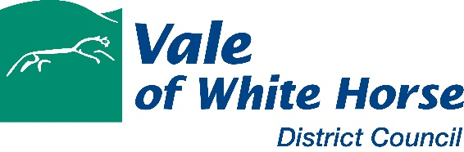

Notes for licence holders

- Vale of White Horse District Council operates a penalty points scheme under which points can be issued to licence holders for breaches of licence conditions or non-compliance with the law as an alternative to prosecution. Full details of the penalty points scheme can be found in the council’s Licensing Policy for Hackney Carriage and Private Hire.
- As a licence holder you have a right to appeal points that have been issued if you do not agree that they were correctly issued or you have information that was not taken into consideration when the decision to issue penalty points was made.
- You have 7 days (including weekends and bank holidays) from the date of receipt of the notification letter to lodge an appeal.
- Please use the form below and return it to the Licensing and Community Safety Manager – contact details are provided at end of this form.
- Your penalty points will be reviewed and the outcome of your appeal communicated to you within 21 days. The decision of this appeal is final.
- Should your licence be suspended or revoked as a result of the points issued, the relevant letter will outline your statutory right of appeal against the suspension or revocation.

Licence holder details

Name

Driver licence number (badge number) or Operator licence number

Address

Telephone number |  | Email

Penalty points details

Date points issued |  |  |  | Date notified of points
Reason for points being issued

Appeal

I do not agree with the penalty points issued to me because:

I have the following additional information to support my appeal:

Signature
Name in capitals

Date

Please now return this form by email to: licensing.unit@whitehorsedc.gov.uk
or post to: Licensing and Community Safety Manager, Vale of White Horse District Council, Abbey House, Abbey Close, Abingdon, OX14 3JE

