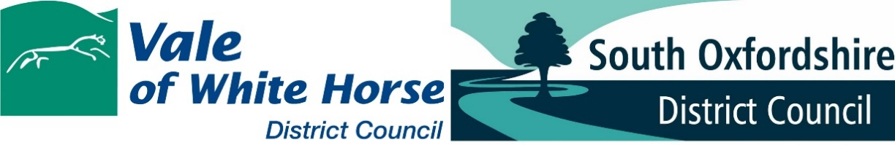

Application for Approval of Reserved Matters following Outline Approval Validation Checklist
Complete this checklist and submit it with your application for approval of reserved matters following the grant of outline planning permission.
You will need to submit this completed checklist with your application. It will not be accepted without it.
Guidance and information on the drawing and documents listed below can be found in our Validation Checklist Guidance Note.
National requirements
Requirement | Included – Y/N | If No, short statement why detail is not required
Completed application form, signed and dated

Completed Ownership Certificate
(A, B, C or D as appropriate) – within application form

Correct application fee

Location Plan

Proposed Site/Block Plan

Existing and Proposed Elevations

Existing and Proposed Floor Plans

Existing and Proposed Roof Plans

Site sections and finished floor and site levels

Design and Access Statement

Fire Statement

Local List Requirements
In addition to the national requirements set out above, the following information may also be required and this is dependent on the particulars of your application and proposal.
Please see the Validation Checklist Guidance Note for further advice on the information which may need to be submitted with your application.
Requirement | Included – Y/N | If N short statement why not required
Acoustic Report/Noise Impact Assessment

Affordable Housing Statement
(housing proposals only)

Agricultural, Rural or Occupational Worker Dwelling Justification and Development

Air Quality Assessment

Arboricultural Assessment/Tree Survey

Archaeological Survey/Assessment

Biodiversity Assessment and Surveys

CIL Form 1 and measurements plan

Contaminated Land Survey and Report

Drainage Report – Foul and Surface Water

Economic Statement

Energy Statement (SOUTH ONLY)

Environmental Statement

Flood Risk Assessment (site-specific)

Heads of Terms for S106 draft

Heritage Statement

Landscape Assessment/LVIA

Landscaping Plan (hard and soft)

Nutrient Neutrality Assessment (VALE ONLY)

Planning Statement

Proposed Street Scene

Recycling and Waste Management Plan

Structural Survey

Sustainable Design Measures Statement/Checklist

Topographical Survey

Transport Assessment/Statement

Viability and Financial Information

September 2022

