Climate Action Fund awards – offered June 2022

Organisation | Description of project
Sustainable Botley | Offering advice to householders on the principal measures they can take to stay warm and save energy on a tight budget, and/or to improve their home energy performance to at least EPC C rating and to carry out ‘DIY’ measures such as loft insulation
Down to Earth Community Café | A pilot programme of ‘Let’s Cook Sustainably’ cooking courses and ‘Climate Cook-Ins’ (community cooking events), adapted for vulnerable groups
Wantage Draught Busters | Offering simple adaptations or repairs to people’s homes to reduce heat loss, without any charge to them. Aiming to target individuals and families who are in, or at risk of, fuel poverty
Sustainable Shrivenham | Establishment of a community hub in the High Street, focused on sustainability. Funding for a hub manager on a six month contract to establish the hub and lay foundations for its success
Marcham with Garford PCC (Parochial Church Council) | Developing the Churchyard area, subject to an Environmental Management Plan, as a demonstration and teaching resource, modelling both care of creation and sustainability
Friends of Abingdon Buildings Trust | Plot to Plate festival - a one day festival aiming to engage people with greener, more conscious and healthier lifestyle choices, focussed on food
The Buck Project Limited | A pilot project working with people who are unemployed with financial challenges, with the aim of being more active, finding ways to reduce waste and saving energy
Stanford in the Vale Parish Council | Rejuvenation of a community garden, transforming it into an area that promotes ecological restoration, allowing people to spend time in nature and appreciate the benefits of the natural world
Greener Great Coxwell | A community energy project with funding for an infra-red camera, outreach materials, events support and training to help community understanding of how and why to save energy
One Planet Abingdon Climate Emergency Centre | Two projects – 1. Free, public knowledge sharing events, featuring a moderated talk by an expert speaker. 2. Working with young people, through a series of facilitated workshops and activities aimed at empowering and supporting them as change agents
Cumnor Conservation Group | Delivery of a habitat survey and resultant management plan, to support and understand the site, as well as increase local knowledge concerning the site, ecological methods in general and forming the basis of a public education drive
Hinksey Trail Regeneration CIC | Building a new 30m section of boardwalk, in sustainable recycled plastic lumber ,next to a small lake that is a popular place for visitors to stop and watch wildlife
The Radley Lakes Trust | Community planting - creating two biodiverse and attractive areas of native species plantings, close to Thrupp Lake

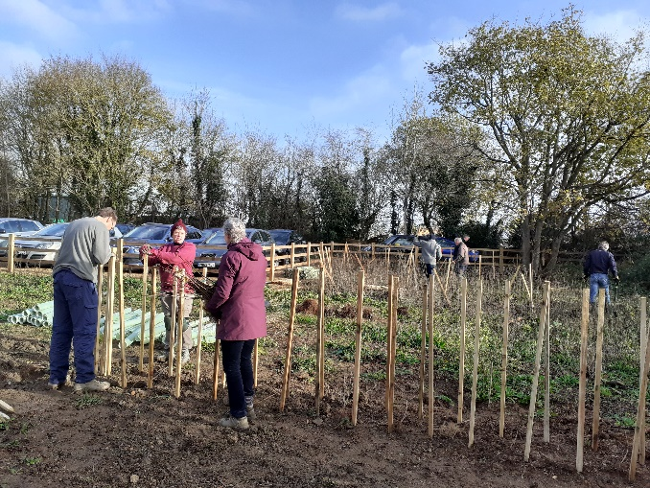
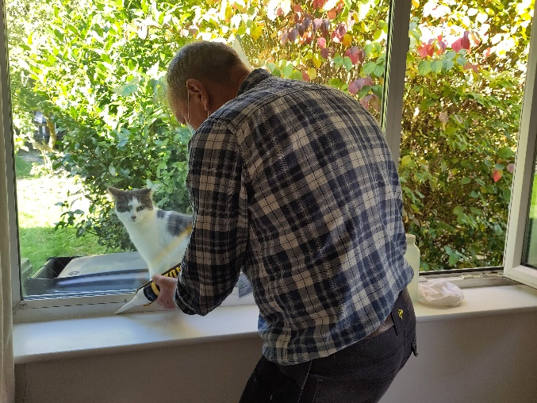
Wantage Draught Busters
The Radley Lakes Trust

